SUBCOURSE EDITION
IT0480 B

US ARMY INTELLIGENCE CENTER

INTELLIGENCE IN SUPPORT

OF INTERNAL DEFENSE OPERATIONS

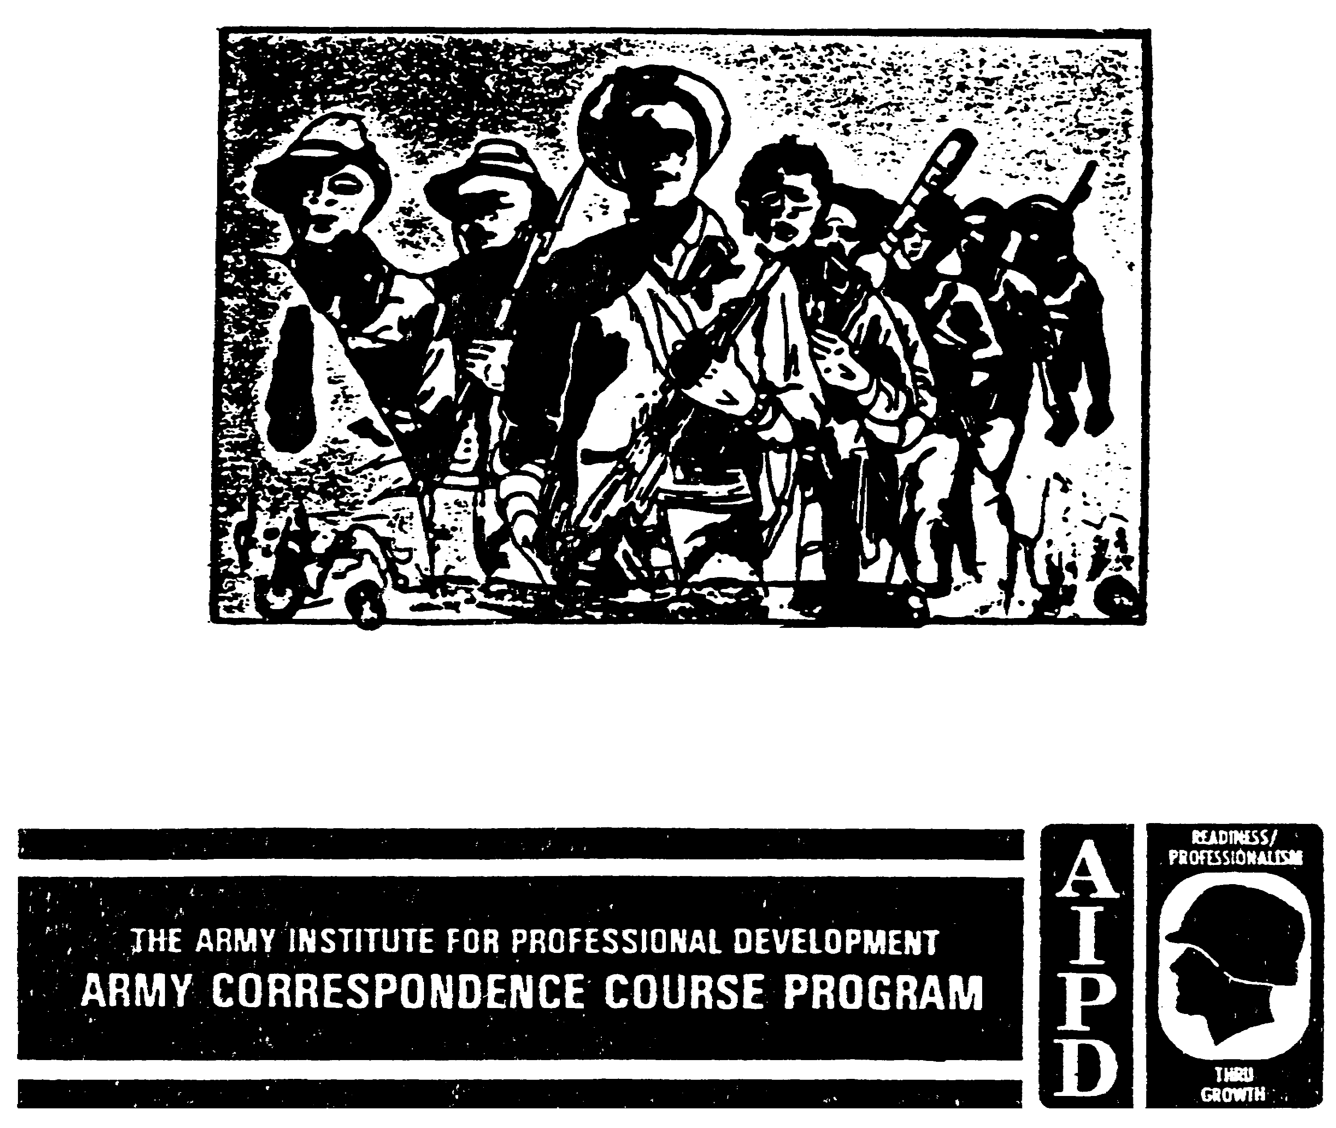
INTELLIGENCE IN SUPPORT OF INTERNAL DEFENSE OPERATIONS

Subcourse Number IT 0480

EDITION B

United States Army Intelligence Center
Fort Huachuca, AZ 85613-6000

6 Credit Hours

Edition Date: September 1998

Subcourse Overview

This subcourse is designed to teach you the role of intelligence in support of internal defense operations including tactical intelligence and planning, counterintelligence, and combat surveillance support in the conduct of internal defense operations.

There are no prerequisites for this subcourse. This subcourse reflects the doctrine which was current at the time the subcourse was prepared. In your own work situation, always refer to the latest publication.

The words "he," "him," "his," and "man," when used in this publication, represent both the masculine and feminine genders unless otherwise stated.

TERMINAL LEARNING OBJECTIVE

ACTION: You will be able to define the types of revolutionary activities and know the four broad categories of insurgency.

CONDITION: You will be given narrative information and illustrations from applicable field manuals.

STANDARD: To demonstrate competency of this task, you must achieve a minimum of 70% on the subcourse examination.

i IT0480
TABLE OF CONTENTS

SECTION PAGE

Subcourse overview

LESSON 1: Insurgency 1-1
Part A: Background of Insurgency 1-2
Part B: Types of Insurgency 1-5
Part C: Insurgent Organization 1-8
Part D: Internal Defense and Development
Strategy, Planning, and Organization 1-12
Part E: internal Defense Intelligence 1-13
Practice Exercise 1 1-24
Answer Key and Feedback 1-26

LESSON 2: Foreign Internal Defense Operations 2-1
Part A: US Army Support of Foreign Internal
Defense Operations 2-2
Part B: Basic and Current Intelligence 2-5
Part C: Coordination Centers 2-6
Part D: Tactical Planning and Collection 2-7
Part E: Counterintelligence Support 2-10
Part F: Combat Surveillance Support 2-11
Part G: Ground Surveillance 2-12
Part H: Aerial Surveillance 2-15
Part I: Intelligence Processing 2-16
Part J: Intelligence Dissemination 2-18
Practice Exercise 2 2-20
Answer Key and Feedback 2-22

Appendix A: Glossary A-1
Appendix B: List of Acronyms B-1
Appendix C: Army Operations Annex to Military IDAD Plan C-1
Appendix D: Intelligence Estimate of Insurgent Situation D-1

IT0480 ii
LESSON 1

INSURGENCY

CRITICAL TASKS: 301-336-3604

OVERVIEW

LESSON DESCRIPTION: In this lesson you will learn the types of revolutionary activities and the four types of insurgency.

TERMINAL LEARNING OBJECTIVES:

TASK: Define the types of revolutionary activities and the four types of insurgency.

CONDITION: You will be given narrative information and illustration from FM 34-3 and FM 100-20.

STANDARD: Revolutionary activities and the four types of insurgency will be defined in accordance with FM 34-3 and FM 100-20.

REFERENCES: The material contained within this lesson was derived from the following publications:

FM 34-3
FM 100-20

INTRODUCTION

The nature of conflict has changed in recent years. It is no longer the exclusive realm of sovereign states, just as control of government is no longer the only goal of belligerents. There is conflict motivated by unreasoning ethnic hatred and desires to be separate or to settle old scores. Criminal groups fight for illegal profit. Increasingly, conflict occurs within the borders of a state rather than between sovereign states. The class-based, ideologically guided insurgency of the Cold War era has not disappeared. It continues in the Philippines, Peru, and elsewhere. Most of what we know of foreign internal conflicts originates in the study of insurgency. That study delved deeply into individual and group motivation to discover why people fight and how their aggression might be overcome. It led to the internal defense and development (IDAD) strategy, which seeks to end internal conflict by correcting the problems that create it. In varying degrees, the process and cure of insurgency are applicable to other kinds of internal conflict and to some international conflicts. This lesson explains the origins and dynamics of revolution. It provides insight into the reasons for conflict and how insurgent organizations mobilize human and material resources from within. It explains how the political process, like a sort of psychological jujitsu, can turn a government's power against itself. It explains what a government must do to defend itself. They concentrate on class-based insurgencies, the type that continues in many places.

Mao Tse-tung and the Chinese Communist Party invented the people's war, the most political of all insurgent strategies. The Communist-sponsored wars of national liberation showed the

1-1 IT0480
effectiveness of attempting to mobilize a whole people against their government. The people's war, as the most sophisticated of insurgent strategies, emphasizes organization and its relationship with the entire population. It is also the most military in its latter stages as it attempts to raise an army within the affected country and to challenge the government on the field of battle. History shows how powerful and effective the Maoist mass strategy template is. Vietnamese communists used it to great effect, and it has been emulated in Peru, the Philippines, and elsewhere. Thus, the mass strategy deserves special attention. The mass strategy blends environments and methods of political violence. In many respects, it is war, especially in its latter stages, but is not the type of war we have known or for which the US Army generally has prepared. The mass strategy combines political and military methods and culminates in a large-scale, nearly conventional war of maneuver. Thus, it is properly treated in a discussion of stability and support operations in the next lesson. Countering the mass strategy requires a similar combination of political and military methods. From this, the IDAD strategy was devised.

PART A -BACKGROUND OF INSURGENCY

Insurgents are citizens of a country attempting by illegal means to change the way it is governed. They believe that the legal methods available cannot satisfy their demands. Thus, they violate the accepted legal processes of government and use illegal means, which are a combination of political, economic, psychological, and military methods. The term insurgency implies some degree of popular participation, distinguishing it from a coup d'etat. An insurgency is usually revolutionary in intent. It aims to replace the current system of government and redirect the society and its institutions. It would change who governs, how, and for what purposes. The following terms aid in differentiating different revolutionary activities:

- Coup d’etat. A governmental takeover by a relatively small group within a nation. It is generally nonviolent, quickly executed, and results in minimal government policy changes.

- Insurrection. A localized activity within a nation whose intent is not to overthrow the government but to force specific policy changes.

- Rebellion. More widespread than in insurrection, it aims at creating a new, independent, self-governing entity through violent means.

- Insurgency. An attempt by an organized element to overthrow the legal government through subversion and armed co-threat.

- Political subversion. Guerilla and terrorist activities and is frequently supported by external activities.

Causes.

If government and other social organizations are generally meeting the needs of the people, there is little cause for revolution. However, if significant numbers of people believe their society is not serving them as it should, they will oppose it by any means available. There is a psychological hierarchy of human needs which provides a virtual psychological rank ordering of what a human being needs most to be satisfied. The general types of needs are physiological, safety, belongingness and love, esteem, and self-actualization.

IT0480 1-2
Relative deprivation can be experienced at any level of the hierarchy of needs. People become angry when denied food, clothing, housing, jobs, or similar economic needs. However, they can become just as angry if they are denied their human dignity or the opportunity for political participation. Any groups subject to social or political discrimination are potential insurgents, and so are people in an authoritarian society who are subject to arbitrary rule. Even though their government may present economic benefits, people may become discontented when they cannot make decisions affecting their own lives.

Since this hierarchy applies to all people, the potential for insurgency or revolution is not limited to the poorest countries of the world. Indeed, it implies the poorest people will devote themselves to basic survival and will not be concerned with political matters. Neither are the causes of insurgency limited to economic problems. In fact, political and social concerns may be more potent revolutionary motives than economics. The necessary conditions for revolution exist when people believe they are being treated unfairly and have no recourse. If a country is poor and people know it but feel they are getting their fair share of what is available, they do not revolt. They accept the situation as the natural conditions of things. When people begin to believe society owes them more than they actually receive, they experience a sense of injustice and relative deprivation. This sense of injustice can occur at any level.

Conditions that can affect a developing nation's ability to satisfy the wants of the populace include:

- Population expanding more rapidly than economic growth.

- Drastically low educational levels.

- Inadequate technical skills and technological know-how.

- Primitive agriculture.

- Lack of investment capital.

- Control of capital assets by foreign nations.

- Lack of raw materials.

- Small or nonexistent industrial base.

- Elite unwilling to share or give up power.

- Inefficient, sometimes corrupt government.

Eastern European countries have experienced high incidences of revolution since the end of World War II. This endemic violence is ironically due to modernization. Insurgencies began with the struggles for independence from their former European colonial rulers. These newly independent countries fought among themselves to realign borders. Later conflicts, which continue today, are concerned with the internal order of these states. The movements for independence were contagious. As soon as one

1-3 IT0480
country demonstrated that foreign rule was not inevitable, others clamored for independence. People were no longer willing to accept the life of hardship their ancestors had known for centuries.

Government attempts to satisfy the people's growing demands actually made matters worse. Government embarked on modernization programs, promising great improvements and enlisting the people in their efforts. Expectations rose more rapidly than the governments' capabilities to satisfy them. The perception of relative deprivation increased, and people turned against their governments.

Relative deprivation and, thus, revolution are most likely to occur when there is a sudden downturn of societal benefits after a period of growth. Originally, the psychology of relative deprivation applies to individuals. Individuals do not make a revolution; groups make revolutions. Revolution occurs when the dissatisfaction of many people coincides and becomes politicized.

First, the dissatisfaction of relative deprivation must be stated and explained. People may feel discontent without fully understanding the cause of their unease. The first job of revolutionary leadership is to put the discontent into words. The leaders say injustice is due to government policy, which is incompetent, or maybe it favors one group over another. They say we can improve things by extending the franchise, adopting a new tax code, or shifting to a different political-economic ideology. Now, the discontent has a name and a face. It has become a set of political issues. People begin to recognize the possibility of solutions. They demand that the government institute changes. The revolutionary leadership organizes these demands and builds groups of people to act together. When these groups are organized and directed toward political goals, they become political forces.

The government responds with programs and issues of its own. It, too, attempts to mobilize groups and forces in its support. The process of gaining and keeping popular support is analogous to an election campaign in a democratic country. Political parties try to identify issues, things they say are wrong with the government and society. They advance programs to solve the problems and attempt to attract supporters to their side, luring them away from the opposition. A democratic government has an effective mechanism to resolve this corruption. Parties develop political platforms and nominate candidates. They debate the issues before the electorate. Eventually, the people go to the polls to vote. The opposition accepts the results.

The political situation becomes especially acute when the society is divided. Racial, linguistic, national, tribal, or other ethnic divisions aggravate the situation. So do social and economic classes, especially when mobility is limited. All these groups form natural alliances, which may be mobilized en masse. For the government to satisfy all of them is difficult because the advantage of one is the disadvantage of another. The insurgent leadership may manipulate these divisions against each other.

Whatever the strategy and tactics, part of the political process of insurgency is developing antigovernment alliances, or "united fronts." One of the ways an insurgent leadership attracts supporters is through ideologies. It uses them to appeal to the social groups and political forces. Ideology is a general theory of problem solving. It outlines a plan to improve the people's lives. Insurgent leaders may be completely convinced in their own minds that their political theories are correct. This ideology defines the limits in which they are willing to operate. However, they may employ a certain amount of studies cynicism. Insurgents seek to manipulate groups and forces

IT0480 1-4
for their own purposes. Thus, they may conceal all or part of their ideology and goals from united front allies.

The political appeal of the insurgents must consider the values of the people. Sometimes insurgents have only a vague idea of the sort of government they will establish when they gain power. Their only goal is short-term: to rid themselves of the incumbents. If the existing government is hated enough, such an insurgency can succeed. The defeat of the old government is likely to result in another battle among rival insurgent parties before a new system is established. This type of insurgency is likely to produce an ideology after victory.

Indicators.

A major indicator of an impending insurgency is the fragmentation of a country's leaders. When the society is failing and there is no agreement on solutions, the leaders divide among themselves. The government becomes unable to count on the loyalty of its own members and employees. Government agencies work at cross-purposes. The executive, legislative, and judicial branches may compete for power. Armed forces often disobey the policies of their governments and pursue their own agendas. The private sector is often divided. Land owners and farm workers may be at odds. Industry and labor may be unable to agree on goals and policies.

Other societal divisions are based on the interests of geographic regions or even age groupings. One of the strongest indications of revolution occurs when a country's intellectuals abandon the existing political system and switch to the government's opponents.

While the potential for revolution indicates an unhealthy government, the disease is not always fatal. A sick government may be able to cure itself; certainly, it will try. It will put up a spirited defense, and if it acts properly, it has a reasonable change to defeat the insurgency. A government would appear to have all the advantages in an early stage of insurgency. It has the presumption of legitimacy that comes with incumbency. It controls the wealth and coercive power of the state. A revolutionary group that challenges a government in power must be committed to its cause and ready to embark on a difficult undertaking.

PART B - TYPES OF INSURGENCY

Insurgencies generally fall into one of four broad categories (See Figure 1-1): politically organized, militarily organized, traditionally organized, or urban-although some insurgencies have characteristics of more than one type. The defining quality of each category is the group's organizational strategy. Differences in organizational approach, in turn, produce differences in the military and political strategies employed by the insurgents at the international, national, provincial, and village levels of the conflict.

1-5 IT0480
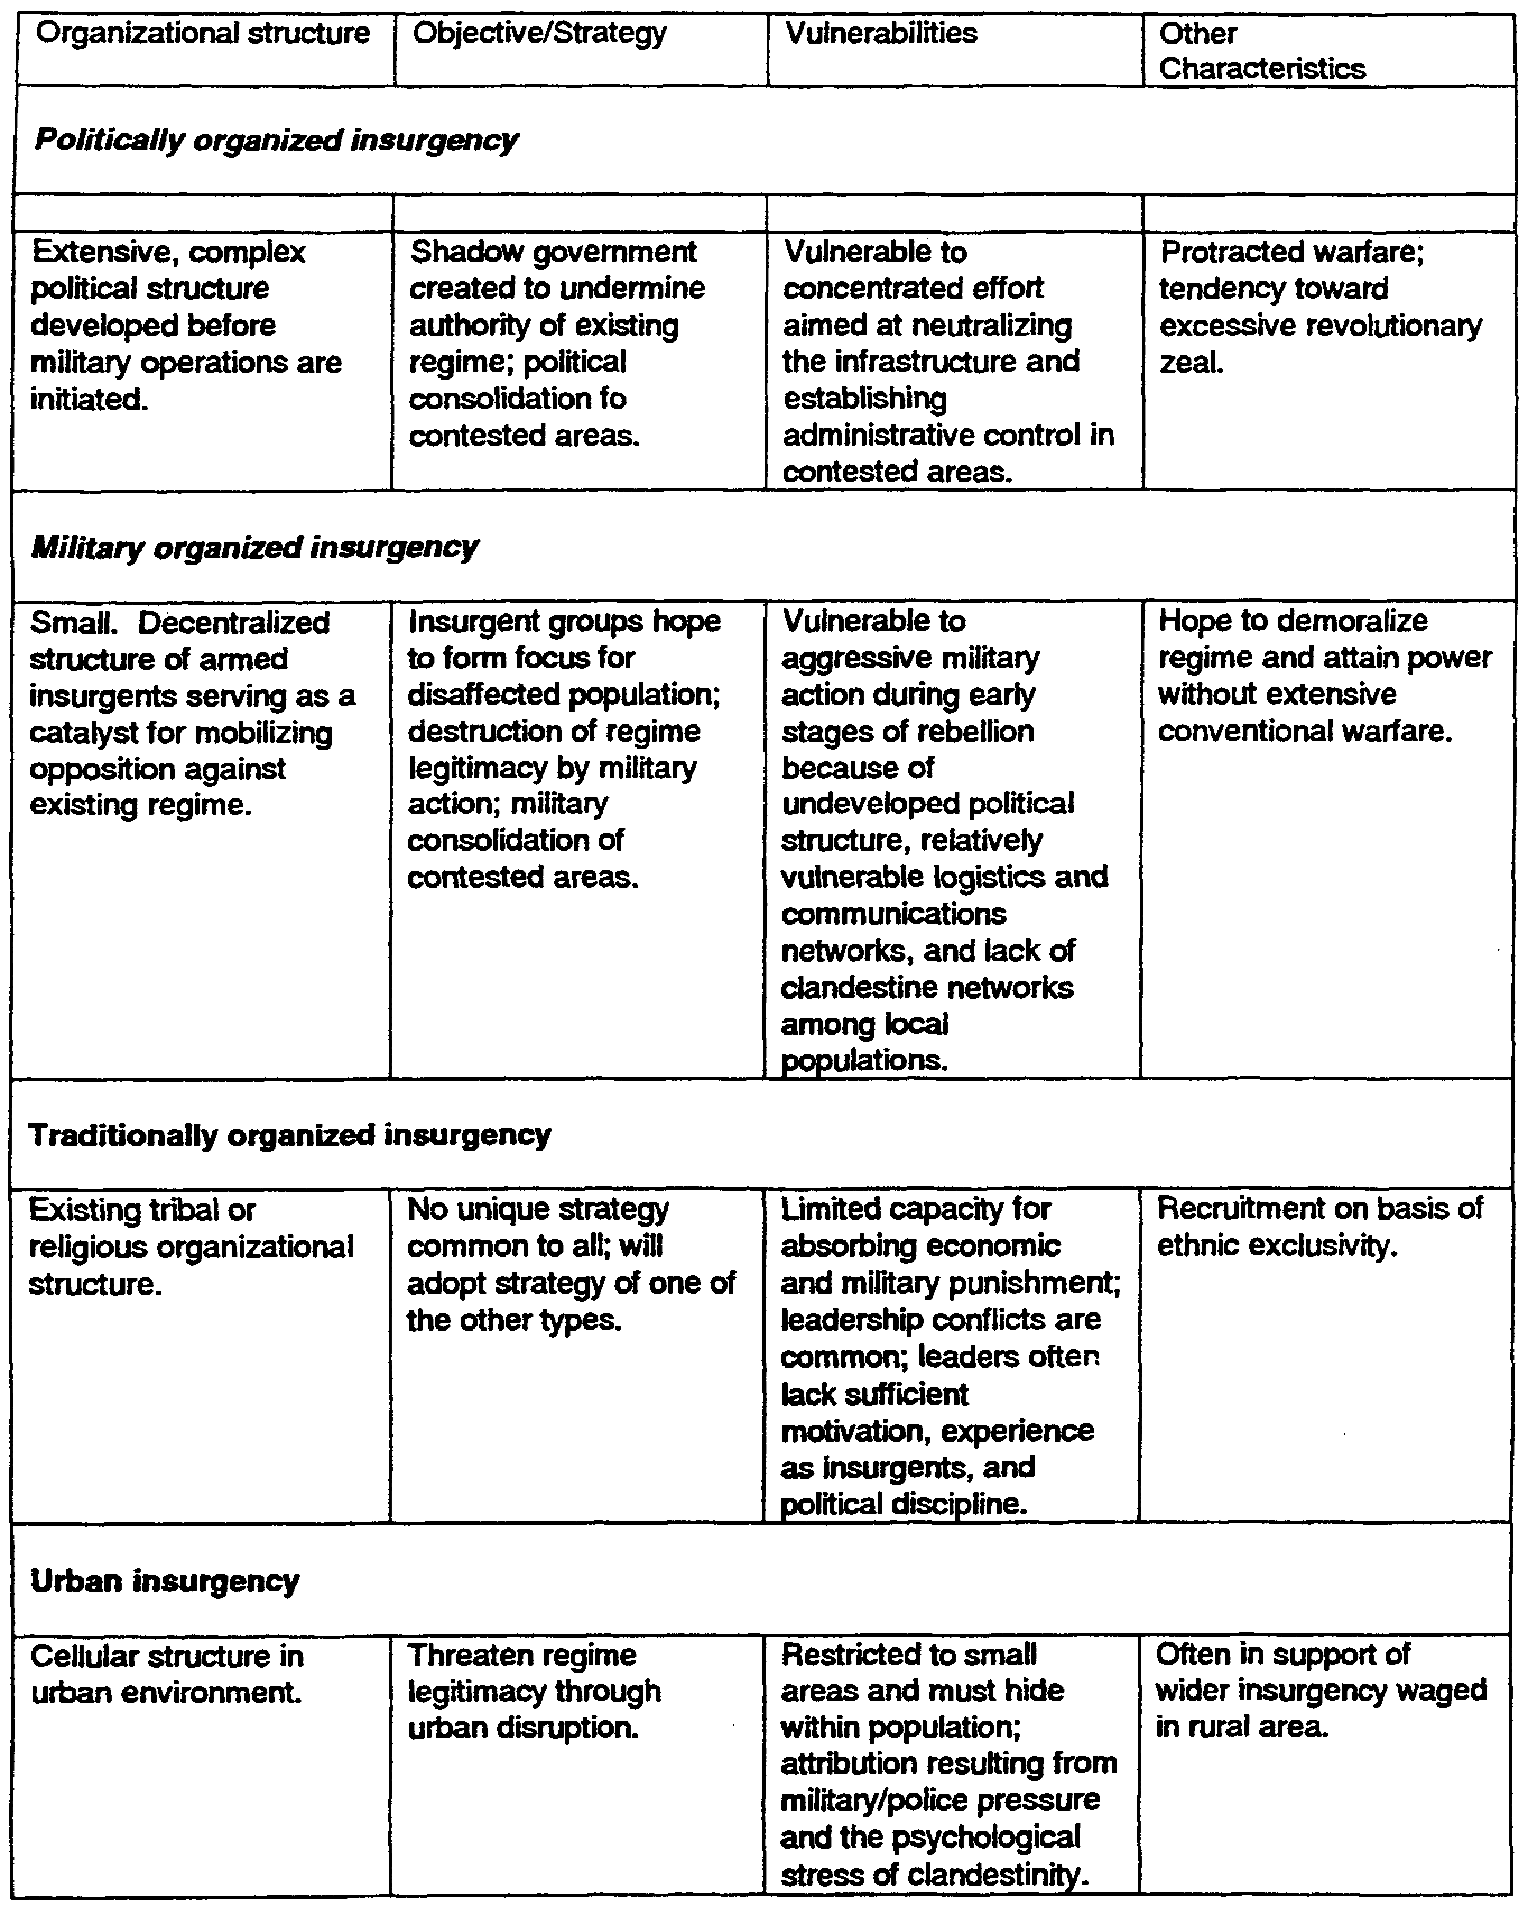

Figure 1-1. The Four Broad Categories of Insurgency

IT0480 1-6
Organizational strategy is determined primarily by the group's operational environment and by the training of its leaders. The operational environment includes the sociocultural make-up of the target population, the economic, political, and geographic characteristics of the area of operations (AO), the insurgents' initial strength, the role of outside parties, and government capabilities. These factors frequently override training and ideology as a determinant of strategy in successful insurgencies; guerrillas who cannot adjust their strategy to suit local conditions rarely survive.

Many politically, militarily, and traditionally organized insurgencies have urban components despite their rural concentration. Insurgent cadres often have strong ties to the cities, and many opposition leaders have attempted city-based revolts before adopting rural-based strategies. An urban component aids a rural-based insurgency by tying up government forces and providing financial, intelligence, and logistic services. Additionally, insurgent "armed propaganda" in urban areas usually receives better media coverage than that perpetrated in the countryside.

Insurgencies of several types may occur simultaneously within the same country. However, differences in organizational strategy, as well as differences in ideology, motivation, leadership, and cadre background, make unification of insurgencies of different types difficult.

The successful progression of armed insurgencies, especially the mass-oriented type, can usually be categorized into three general phases:

- Phase I. Organization. Like all insurgencies, the mass strategy begins from a poverty of resources. Its first task is to organize itself and create political, economic, social, and military assets from within the country. This initial phase can be properly labeled the organization stage. It has also been called latent and incipient, suggesting inactivity, but nothing could be further from the facts. The organization stage is a period of intense activity, laying the groundwork from which subsequent stages develop. Without it, nothing else could be done. If the government is particularly unpopular and weak, this stage alone could bring it down. An insurgency is most vulnerable during the organization phase. If the government recognizes its existence and has the will and determination to oppose it, the insurgency can be defeated at this stage with relative ease. Governments, however, are reluctant to admit an insurgency exists until it can no longer be denied. Recognition of insurgency tends to bestow legitimacy on it and acknowledge government weakness. Insurgents formulate ideology and organize leadership relationships. The insurgents normally have a covert element, regardless of whether they are operating legally or illegally. The insurgents use PSYOP to:

- Exploit grievances.

- Heighten expectations.

- Influence the populace.

- Promote the loyalty of insurgent members.

1-7 IT0480
As the insurgents consolidate their initial plans, their organization coalesces into a shadow government. After this they concentrate on:

- Gaining influence over the populace.

- Infiltrating government, economic, and social organizations.

- Challenging the government's administrative ability.

- Recruiting, organizing, and training armed elements.

- Phase II. Guerrilla Warfare. The organization phase blends into the guerrilla warfare phase. Organizational strength and discipline continue to grow. As capabilities increase, the number and size of guerrilla attacks increase. Sabotage and terrorism continue at a heightened pace. Propaganda is intensified. The insurgents drive government officials out of local areas in search of safety. As the insurgents gain control over geographic areas, they develop them into bases for further operations. The insurgent political organization begins to establish its legitimacy, setting up a shadow government and seeking international recognition and support. This phase occurs when it gains sufficient local external support to begin organized guerrilla warfare or related forms of violence against the government. The insurgents' major military goal is to control additional areas. The government becomes entangled in protecting areas simultaneously while insurgents destroy LOC and capture or destroy government resources.

- Phase Ill. War of Movement. The final phase is what Mao Tse-tung called war of movement. Guerrilla bands combine into regular forces of battalion, regiment, and higher strength. The guerrillas acquire more powerful and sophisticated weapons from foreign assistance and by capturing them from the government. Insurgent military forces challenge the governments army directly in battle. Areas of insurgent control expand and political activity increases. Ultimately, the insurgents defeat the government's forces, whose morale and discipline have been undermined by subversion, numerous small defeats, withdrawal of popular support, and loss of confidence. This phase is primarily a war of deployment of forces between the insurgents and those of the established authority.

The phases of insurgency do not follow a rigid sequence or timetable. Success might come in any phase, depending on the government's reactions. Likewise, the insurgents will experience defeats and other setbacks, causing them to retreat to an earlier phase. In bad times, the insurgents will reduce their level of activity, only to come back in strength when they have recovered and improved their capabilities.

PART C - INSURGENT ORGANIZATIONS

An effective organizational structure is essential if the insurgency is to spread its political ideology and secure new members. Competent leadership is required to unify the efforts of various groups and provide guidance over their activities. See Figure 1-2 for the organization of a mass-oriented insurgency.

IT0480 1-8
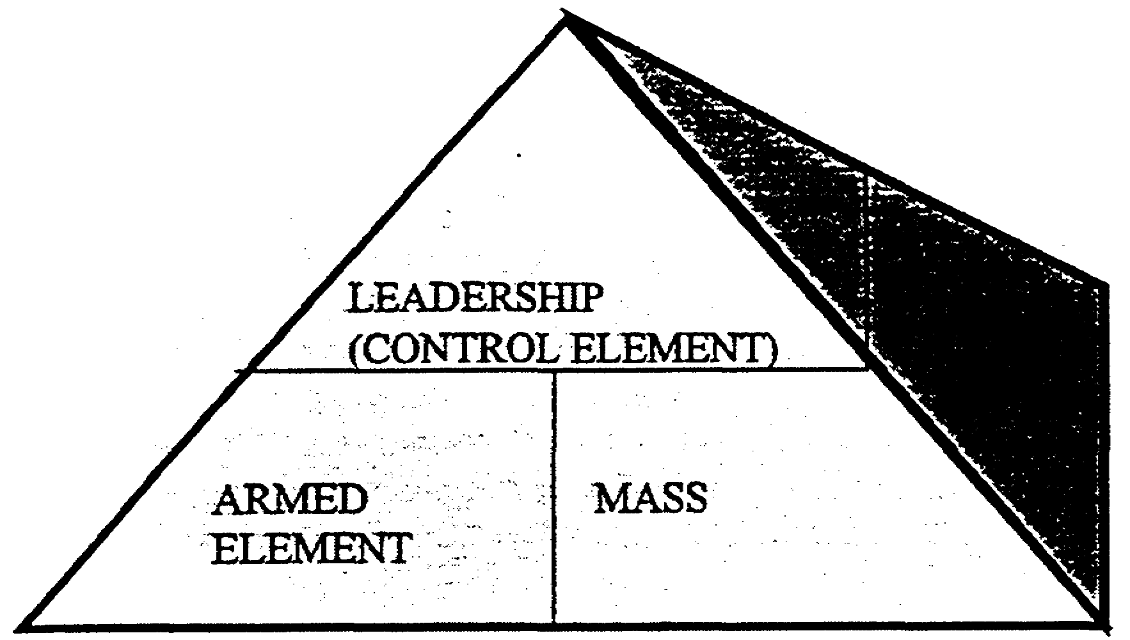

Figure 1-2. Organization of Mass-oriented Insurgency.

An insurgency using the mass strategy organizes into three parallel hierarchies: the political party, the popular control mechanism, and the military organization. Both overt and covert party members hold key leadership positions in the military and popular organizations. Through them, the political party controls the other two organizations at every level-national, regional, and local. The party makes policy and directs both political and military operations. The highest political organization is usually overt so it can seek foreign assistance and promote the insurgents' cause in the international diplomatic arena. Lower echelons of the political party are covert and compartmentalized for security.

These three elements-political, popular, and military-make up the structure of a mass insurgency. The mass strategy is distinguished from other strategies by the clear lines of separation among these three elements. The political party must approve decisions of the other elements at every level. Whenever there is a conflict among the components of the insurgent organization, political requirements take priority.

The Political Party

The cell is the basic party organizational unit. It consists of a small group of individuals who work together on party assignments. Only the cell leader knows the identity of higher party officials or the membership of other cells. This compartmented organization prevents compromise if a cell is penetrated or its members captured. A prisoner cannot tell what he does not know. A party member usually belongs to two or more cells-the local party cell and one or more functional cells such as those in schools, factories, or trade organizations.

Party groups control and coordinate the activities of two or more cells. Each party group, in turn, is responsible to a higher office, the interparty committee. This committee is responsible to its counterpart committee at the next higher political echelon. The chain of command within the party structure extends downward from the central committee at the national level through interparty committees at national, subnational, and local levels. The local party organization has its own paramilitary element, which is discussed in the section on the military organization.

1-9 IT0480
The Popular Control Mechanism.

An insurgency following the mass strategy builds popular organizations to gain control of the people and mobilize support. The whole population, minus identified enemies, is invited or even coerced to join. Many of the members may be unaware of the party's control over the organization and its intended use of it. Party members hold major offices in the mass organizations to ensure central political control over the popular elements. The party includes auxiliary organizations such as labor unions and farmers', women's, and youth groups to extend their appeal and control. Other functional organizations provide specific supplies and services to the insurgency. If a united front is formed with other parties, it becomes part of the popular control mechanism.

The Military Organization

Military units are organized on national, regional, and local levels. All are subject to a dual chain of command. The military hierarchy is made up largely of party members who hold key command and staff assignments. They are responsible both to higher military authority and the political apparatus at the same organizational level. Military plans and orders are formulated to implement party policy. Political considerations have a higher priority over purely military considerations in all military actions and at all levels of command.

The central authority controls main force units, which serve any place in the country. They are usually the best trained and equipped of the military forces. Main force units are the principle offensive arm of the insurgency. They are organized into battalions, regiments, and higher echelons and include all the arms and services. Some of their soldiers are recruited by promotion from lower-level military organizations.

Regional force units are responsive to the military chain of command and the intermediate level of the party organization. They serve in their subnational geographic region. They attack government targets within their capabilities and support main force units. Regional forces receive recruits promoted from local forces and provide personnel by promotion to main force units. Regional forces usually operate at battalion level.

At the lowest level of the regular military organization are the local force units, which respond to the directions of the military chain of command and the local party organization. They serve in their own hometowns, villages, or rural areas. They are the poorest-trained and-equipped of the military units. They provide local security and enforce local party policy. They provide intelligence and support to regional and main force units operating in their area.

Local militia are completely separate from the military organization. They are part of the popular control organization and function much as the local force military units. However, their actions are primarily political. They take direction form the party organization, not the military chain of command. They protect the local party apparatus, keep local citizens in line, and coerce and intimidate local supporters of the government. The local militia are a permanent presence at the city, town, or village level. They are political organizers and propagandist as well as police enforcers and providers of security for the local party apparatus.

IT0480 1-10
The insurgent struggle represents a particular adaptation of revolutionary strategy in a specific time and place. Its effectiveness, however, cannot be denied. US Army officers dealing with the mass strategy of insurgency must understand it, at least in basic concept. They must also be aware of possible applications in other forms of conflict below the threshold of war.

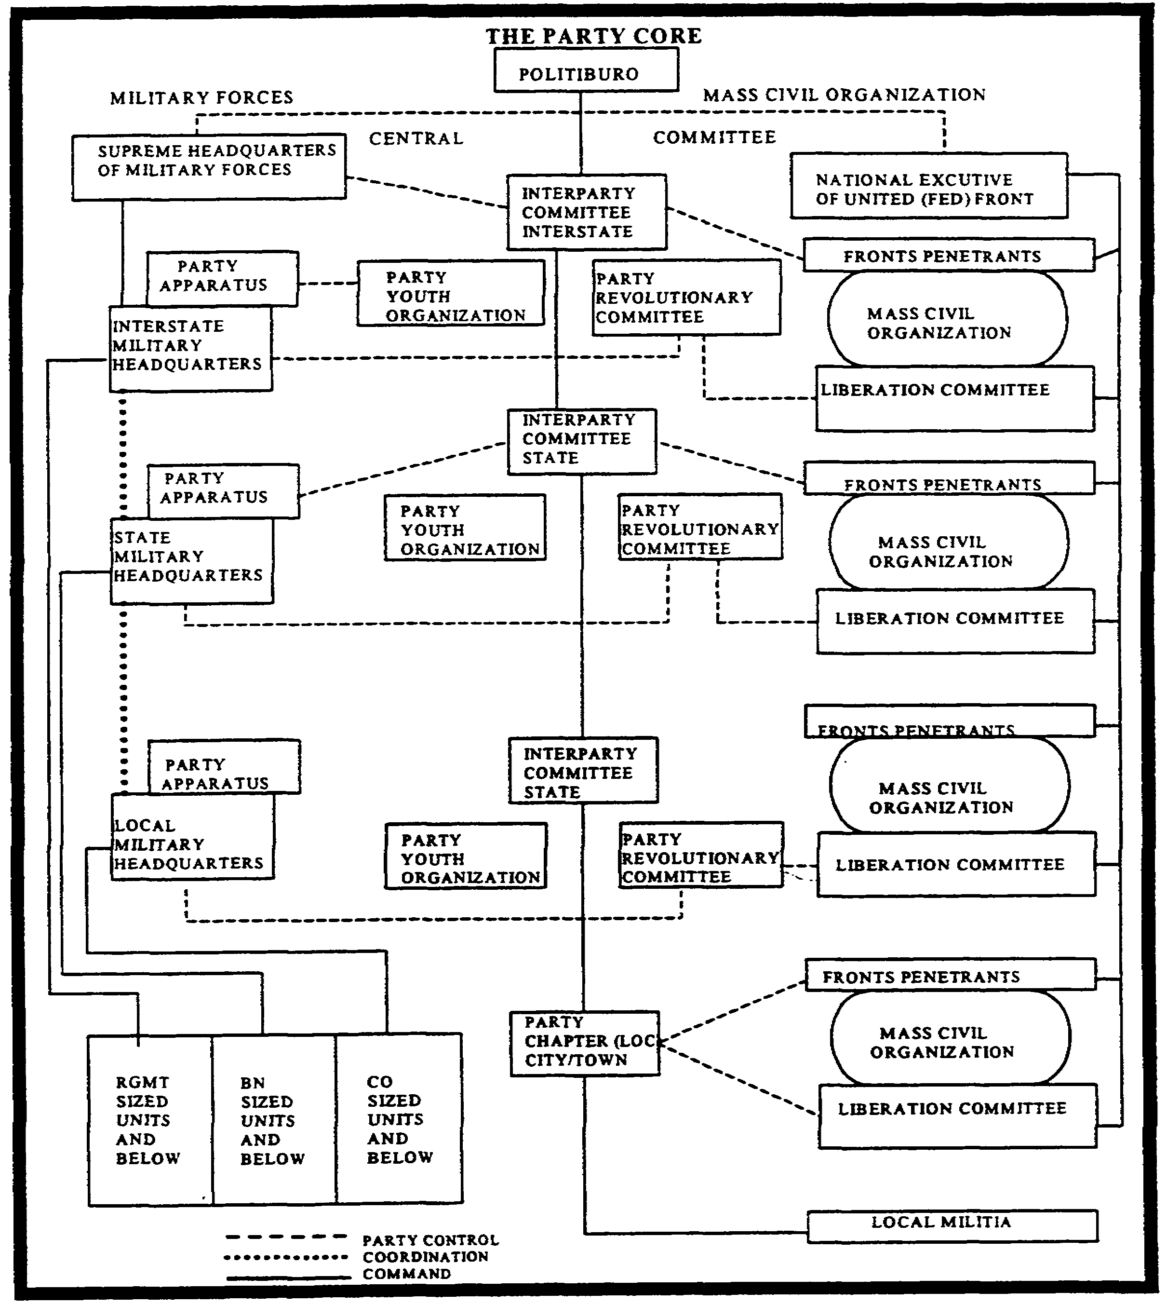

Figure 1-3. Politically Organized Insurgent Infrastructure.

1-11 IT0480
PART D - INTERNAL DEFENSE AND DEVELOPMENT STRATEGY PLANNING AND
ORGANIZATION

Host country IDAD doctrine is designed to prevent insurgent movements. This is done by counteracting the threat posed by an insurgent organization and by alleviating conditions that create populace unrest and promote violence. Should an insurgent movement develop, the emphasis would be on holding down the amount of violence or terrorist activity that would ensue. IDAD Strategy dictates the use of political, economic, psychological, and military powers of the host government, including security forces to prevent or defeat insurgency. The US concept is based on the strategy of using simultaneous IDAD programs to attain internal security. The four dependent components of IDAD strategy are: Balanced development, security, neutralization, and mobilization.

- Balanced development attempts to achieve national goals through balanced political, social, and economic development. It includes activities to alleviate frustration by providing opportunities to individuals and groups within the society.

- Security includes all activities to protect the populace form the insurgent and to provide a secure environment for national development. The primary purpose is to destroy the leadership and control element of the insurgent movement.

- Neutralization includes all lawful activities to disrupt, disorganize, and defeat an insurgent organization.

- Mobilization includes all activities to motivate and organize the populace in support of the government.

Internal defense planning requires knowledge of the insurgent threat and close coordination between the civil and military community. Planning includes support from the armed forces and the efficient integration of external assistance from free world nations, if required. The host country's defense establishment should prepare the military plans for the IDAD program. It should include information on plans for the police and other security forces that the host country may possess. The military plan should include several operational annexes, one of which will be the intelligence portion. This portion should contain the following:

- Available intelligence assets.

- Guidance for the collection, processing, and dissemination of intelligence concerning the insurgent, weather, terrain, and population.

- Intelligence requirements pertinent to the psychological operations (PSYOP), civil affairs (CA), and communications security (COMSEC).

IDAD Organizational Guidance provides centralized and coordinated direction to the host governmental agencies. All planning, organization, and control should follow the established political organization of the country. Responsibilities of the three organizational levels are:

- The National-level organization. This is concerned with the overall threat to the nation and total resources available for employment in IDAD. The intelligence office is one of the major

IT0480 1-12
offices established for IDAD planning and coordinating. It provides general guidelines on intelligence relating to national security. This office is staffed mainly by representatives from intelligence agencies, police, and military intelligence.

- The Subnational-level Organization. This may establish area coordination centers at the state and local levels. These centers exercise operational control over all military forces and government civilian organizations within their respective areas of jurisdiction. Normally, local and national intelligence organizations are included in the area coordination center.

Coordinating centers are not intended to replace or perform the functions of government agencies but to provide focal points for planning and coordinating the counterinsurgency effort. Civilian advisory committees are composed of government officials and leading citizens, who help the coordination centers at all levels by evaluating the success of their activities and by helping to gain popular support These committees evaluate the results of various actions affecting civilians and provide a communications link with the people, thus providing feedback on which to base future operations.

PART E - INTERNAL DEFENSE INTELLIGENCE

The primary responsibility of intelligence personnel engaged in internal defense operations is to produce intelligence aimed at preventing or defeating an insurgency. To defeat an insurgency, information must be collected, processed, and intelligence produced on virtually all aspects of the internal defense system. When insurgents are receiving aid from an external power, it is necessary to obtain information on the role of that external power in the insurgency. To counteract an insurgency, the established government must maintain the support of the people. IDAD programs, therefore, must be well planned, implemented, and supported. Good intelligence is essential to accomplish this. In support of IDAD programs, the intelligence mission provides assistance to the Army in six specific areas:

- Intelligence Operations.
- Psychological Operations (PSYOP).
- Populace and Resource Control.
- Civil Affairs (CA) Operations.
- Tactical Operations.
- Advisory Assistance.

Intelligence Operations.

The direction, collection, processing, and dissemination of information about all aspects of a nation susceptible to insurgency are essential to successful IDAD operations. Military intelligence operations, coordinated with other host country IDAD operations, must begin as early as possible to counter a potential or active insurgency. Of particular importance are intelligence operations directed toward neutralizing or destroying the effectiveness of the insurgent infrastructure and establishing a data base in preparation for whatever roles the military is required to plan in defeating the insurgent movement.

1-13 IT0480
IDAD operations are dependent upon intelligence and counterintelligence activities because subversive insurgency relies on the country's population for success. The population is both a target of the insurgent and a principal source of his intelligence, cover, personnel, and logistical support. This is why the people are considered to be a major consideration of intelligence along with the traditional considerations of the enemy, weather, and terrain. Intelligence operations support IDAD planning and operations by providing general and specific information about the AOs and the insurgent forces. In broad terms, early intelligence objectives are to:

- Determine the indicators of an impending insurgency.

- Obtain information concerning the insurgent, weather, terrain, and population.

- Reduce to a minimum insurgent espionage, subversion, and sabotage.

A unified, centralized intelligence system is essential to the effective conduct of IDAD operations. While maintaining the capability for the highest level of intelligence activities, operations must effectively employ both intelligence and counterintelligence measures. At the national level the intelligence structure should:

- Operate freely throughout the nation.

- Have a central registry of intelligence information.

- Maintain a centralized system of source control.

- Coordinate all intelligence and counterintelligence programs.

- Provide direction, collection, processing, and dissemination for the intelligence effort.

- Prepare national intelligence and counterintelligence plans and estimates.

- Conducts covert operations as directed.

Basic intelligence on a specific area and situation is derived from strategic intelligence reports and studies augmented by available information of the area. This is the basis for the estimate of the situation and subsequent plans.

Planning for production of intelligence is a continuous task at all levels as military operations can be initiated at any time. Intelligence collection planning for IDAD involves three key efforts:

- Gathering strategic intelligence concerning the actual or potential insurgent and the population as derived from political, economic, and sociocultural developments.

- Assessing and exploiting insurgent infrastructure to include its command, control, and communications (C3) structure, recruiting system, logistic support, and mass civil organization collection efforts against these activities can lead to early detection and identification of key members of the infrastructure.

- Focusing all source collection, threat intelligence and information on the area specifically on the commanders needs. The objective of intelligence production is to provide accurate and

IT0480 1-14
timely intelligence that satisfies military and civil requirements at each operational echelon. There must be a steady flow of intelligence information to and from higher, lower, and adjacent headquarters and agencies. This requires constant coordination between military and civilian police and intelligence organizations. Intelligence requirements vary according to echelon, user, and mission. No single format is adequate for all users; therefore, production programs must provide several degrees of detail. Determination of production objectives and priorities requires careful analysis.

Psychological Operations.

Since both government and insurgent forces need the support of the people to accomplish their programs, a major struggle often results between them for the people's support. Therefore, PSYOP are employed against the insurgents. PSYOP are dependent on the availability of timely, continuous, accurate, and detailed intelligence at all levels of command. PSYOP intelligence needs are integrated into the overall intelligence effort. For PSYOP to be effective, qualified PSYOP and intelligence personnel must work together.

The following are some tasks PSYOP perform in support of intelligence operations:

- Exploit war weariness among the military and civilian population.

- Identify and exploit enemy mistakes using propaganda.

- Identify enemy propaganda, its approaches, and themes.

- Identify differences and hostilities in enemy groups.

- Overcome the effects of enemy indoctrination.

- Locate other PSYOP opportunities to support the host government.

PSYOP are designed to support national objectives and are directed toward the following target groups: insurgents, civilian population, military forces, neutral elements, and external hostile powers.

- Insurgents. The major objective is to discredit the insurgents and isolate them from the population by creating dissension, disorganization, low morale, subversion, and defection within insurgent forces. Host country programs designed to win insurgents over to the government's side are emphasized.

- Civilian Population. This is the major target of the insurgency and the government alike.

- The PSYOP mission is to build national morale, unity, and confidence in the government, its leaders, and programs.

- Military Forces. To gain, preserve, and strengthen military support with emphasis on building and maintaining the morale of these forces. Their loyalty, discipline, and motivation are critical.

- Neutral Elements. These elements are targeted to gain the support of uncommitted foreign groups inside and outside the host country by revealing the subversive activities, and brining international pressure to bear on any external hostile power sponsoring the insurgency.

1-15 IT0480
- External Hostile Powers. The objective is to convince the external hostile power that insurgency is hopeless.

Populace and Resource Control.

These control operations are policy-type operations directed primarily against the insurgent apparatus by controlling the populace and the resources of the nation. This program is designed to complement and support other IDAD operations. The objectives of a populace and resource control operation are to:

- Mobilize the material and human resources on behalf of the government.

- Detect and neutralize the insurgent infrastructure and activities.

- Provide a secure physical and psychological environment for the population.

- Sever the supporting relationship between the population and the insurgent.

Essential populace and resource control measures that conform to legal codes must be established and enforced justly and firmly. These include laws regulating possession of certain items, the mobility of people, and the disposition of contraband materials. These controls must be properly enforced and supervised to prevent graft and extortion that could further alienate the people. Some populace and resource control measures are:

- Employing population surveillance (overt and covert) based on area coverage.

- Controlling movement of both personnel and materiel.

- Establishing checkpoints and roadblocks.

- Establishing curfews and blackouts.

- Screening and documenting the population.

- Conducting cordon and search operations.

- Controlling refugees and displaced persons.

- Protecting resource storage areas from insurgent attack.

- Identifying and controlling sensitive material that is to be denied to the insurgents.

- Establishing physical security measures.

Intelligence has a function in the populace and resource control program beyond that of providing information. This is the function which involves identification and neutralization of the subversive underground organization. The underground organization is neutralized by removing its members from contact with the target population. Insurgency is best defeated not be inflicting maximum casualties on its guerrilla forces and front organizations, but by selectively targeting individual members who are involved in policymaking, planning, and supporting guerrilla forces and mass front organizations.

Intelligence must provide information leading to the permanent neutralization of the underground organization while protecting the image of the existing government. For these reasons, the information must be geared to induce underground members to work for the government against their former

IT0480 1-16
comrades, to apprehend, convict, and imprison underground members, or to discredit them sufficiently to prevent their future use by insurgent forces.

Before the subversive individuals and groups can be neutralized, they must be identified through investigation of individual suspects and by penetration of the subversive organization. Informants among the population provide intelligence personnel with leads for investigation. Leads are also obtained by imposing restrictions on the movement and activities of the population. For example, violators of a curfew automatically become suspects and subjects of investigation.

Penetrations of underground organizations are accomplished by inserting agents into the organization. This is a clandestine operation in which the agent poses as an ordinary citizen in sympathy with the insurgents. The technique does not always work, but sometimes the agent is recruited by the insurgents, becomes an active member of the organization, and is then in a position to monitor its activities and identify members of the organization or at least furnish leads for investigation. By penetration and investigation, sufficient evidence is produced to identify suspects as actual members of the underground. They can be neutralized. The actual neutralization should be accomplished by arrest, trial before civilian court, and conviction under a legal statute.

Occasionally, neutralization is done by other means. The most desirable would be to recruit the target to become a government agent, a rare and difficult but extremely valuable information asset. Another method which preserves the information of the target, and thus the government's access to the information, is to cause the target to defect to the government. This might be accomplished by a combination of promises and threats. The target could be informed through leaflets or word-of-mouth that his identity is known, that he will soon be the target of capture, and that the government is offering him personal amnesty and financial rehabilitation assistance to begin a new life in a government area.

Other neutralization methods include publicizing the target's mistakes or his participation in heinous acts of violence to frighten him into inactivity or flight by discrediting him in the eyes of his superiors or in the eyes of the populace in his operational area. Since underground leaders frequently travel in the company of armed guerrillas, some of these leaders are bound to be killed in the normal course of combat. Some underground leaders are so adept at stealth and cover that repeated attempts to capture them fail. In these cases, the only practical way to stop their subversive activity may be to emplace armed ambushes on trails they use. It is extremely important, however, that all personnel recognize that underground leaders represent an extremely valuable informational asset once captured. They possess specific information concerning their own adjacent and higher insurgent cells which could lead to more neutralization operations.

Civil Affairs Operations.

These operations are a responsibility of government agencies and military commanders at every echelon in an insurgent situation. Civil affairs include any activity of command concerned with the relationship between military forces, civil authorities, and the people in any specified function or the exercise of authority by military forces which normally is the responsibility of local government. The overall objective of civil affairs in counterinsurgency is to mobilize and motivate civilians to

1-17 IT0480
assist the government and military forces. Civil affair goals on the part of military commanders should be to:

- Make the military more popular among the civilian population so it can operate without fear of betrayal and use the population as a valuable source of information against the insurgent.

- Demonstrate, through military civic action, genuine concern on the part of the host nation for the welfare of the people.

Threatened governments conduct developmental programs to improve social, political, economic, and military problems throughout the country. Programs are aimed at removing the causes of popular discontent and obtaining the loyalty and support of the populace for the government, while denying it to the insurgent These programs can only succeed when they are well planned and executed to relieve existing problems in a way acceptable to the people affected. Planning is heavily dependent on accurate and timely intelligence information concerning the grievances of the people and the effects of their discontent and of the problem itself on social, economic, and political stability.

Intelligence information is constantly required to effectively plan, conduct, and evaluate developmental programs. Through such programs, properly publicized, the people can be convinced that their interests are being addressed by the government, thus depriving the insurgents a base for popular support. In economic development, the government must create an environment which will encourage economic growth, attract foreign capital, and provide a base for a stable currency. Training and education perhaps are the most significant aspects of remedial political development programs, as they provide a continual flow of knowledgeable people into the various branches of public administration. Major areas of social development that require attention are health, education, urbanization, population, leadership, status, citizen groups, land reforms, and housing. None of these programs can be successful unless intelligence provides intimate knowledge of conditions and the effect of programs intended to improve such conditions.

Tactical Operations.

Tactical operations are the most violent and extreme of all the activities employed in counterinsurgency. They are the primary operations used to conduct the strike campaign, and are employed to support consolidation campaigns. They are not an end unto themselves. The objective of tactical operations is to destroy or neutralize insurgent tactical forces and bases, and to establish a secure environment in which balanced development programs can be carried out Tactical operations are coordinated with civilian agency operations and rarely conducted as independent, sporadic actions aimed solely at the elimination of insurgents. They are conducted as part of a larger campaign involving the employment of other internal defense and internal development forces in the attainment of broader objectives.

Organization should stress tactical self-sufficiency and provide adequate combat support (CS) and combat service support (CSS) elements to conduct semi-independent or independent operations. Intelligence provides information on hostile forces, weather, terrain, and civilian populace in the combat area, and enables tactical commanders to conduct effective campaigns. The isolation and destruction of guerrilla forces call for a very thorough intelligence capability on the part of military forces. Just as the principles of war do not change, intelligence principles remain constant. Because of the nature

IT0480 1-18
of guerrilla warfare, a number of aspects in developing intelligence in an insurgent situation differ from those found in conventional warfare. There are also significant differences in the degree of importance placed on counterintelligence n the two environments.

In conventional warfare the tactical commander must know the enemy, weather, and terrain of the area for planning conducting operations. In this case, intelligence answers the questions represented by the order of battle factors: enemy composition, disposition, strength, tactics, training, logistics, combat effectiveness, personalities, and miscellaneous data. The commander of IDAD forces requires this same type of information, but there is a difference in criticality of information to the operation, and in the difficulty of obtaining it. In a conventional situation, the enemy's strength, training, and equipment are just as important to the commander as the enemy's troop disposition. The enemy troop disposition is not too difficult to determine, since his general location can nearly always be presumed to be reasonably close and in front of friendly opposing forces. Specific location of the enemy can be determined without too much difficulty by aerial and ground reconnaissance.

In IDAD operations, the primary intelligence concern is locating the guerrilla force. Experience has proven that when the guerrilla is found and fixed by conventional forces, he will be defeated. Current location is important, but more critical is the probable immediate future location of a guerrilla force. The desired information must come from individuals familiar with the guerrilla's planned movements. Herein lies the crucial point of the intelligence problem in supporting counterguerrilla operations. It is not an easy one to solve.

The difficulty in distinguishing friend from foe represents one of the most troublesome intelligence problems for counterguerrilla forces. Sometimes the peasant farmer by day is the guerrilla by night. Therefore, it becomes important in collecting combat intelligence for the counterguerrilla force to accurately identify the enemy. If the countersubversion efforts extend into the rural and remote areas as it should, it will reveal not only members of the underground organization supporting the guerrilla force, but also guerrillas who pose as nonguerrillas. Identification is a definite requirement in the collection of combat intelligence in an insurgent situation. Therefore, all available intelligence and counterintelligence assets should be brought to bear on the problem.

Conventional warfare tactical operations are conducted in a combat zone from which civilians have for the most part been cleared. In the IDAD defense and development situation, there is no clearly defined line of contact between opposing forces, and operations are conducted in areas still inhabited by the civilian populace. The guerrilla depends on this population, either by persuasion or coercion, for support in the form of supplies, information, and for personnel to augment its force. Countless examples from past and ongoing insurgencies in Malaya, Philippines, Vietnam and Central America indicate that the guerrilla prepares exhaustively for each operation. An important part of this preparation is a careful study of the civilians in the area to determine their political leanings-who could be incorporated in the operational plan, who should be avoided. The population is in contact with the guerrillas and it is a potential source of critical information for the counterguerrilla force. Therefore, the population becomes a major target of intelligence in support of counterguerrilla operations. For these reasons, tactical intelligence in an insurgency must consider the people as well as the enemy. The people represent the most lucrative source of information during all phases of an insurgency.

1-19 IT0480
One of the most abundant sources of information of tactical intelligence value in conventional warfare is enemy activity. Since counterguerrilla forces cannot readily identify their enemy, and often do not know where he is, enemy activity cannot be focused on as a major source of information. However, some data concerning modus operandi, strength, training, equipment, and morale can be obtained through observation and analysis of enemy activity. It is important that the guerrilla's methods of operation be determined early in the conflict so that proper counter tactics can be developed and the counterguerrilla force be trained in the ways of the guerrilla and the methods to be used against him. Experience has proven that personal characterized and the modus operandi of guerrilla leaders may vary considerably from one leader to another. Therefore, this information must be collected early and must be comprehensive. Before a satisfactory relationship has been established between counterguerrilla forces and the civilians, ground patrolling (such as commonwealth forces used in Malaya) is often a good method of obtaining information. Because these patrols establish and maintain contact with local civilians, they are instrumental in developing the civilian population as a source of information.

Captured and surrendered (defectors) insurgent personnel are valuable sources of information for counterguerrilla forces. In addition to general information, such personnel may occasionally be able to furnish that critical element of information-the immediate future location of the guerrilla. Captured and surrendered personnel, especially the latter, can be used with excellent results as clandestine agents against the guerrilla forces, the insurgent cadre, and hostile civilians. However, they must be carefully screened and controlled to ensure that they do not act as double agents for the guerrilla forces. Easy identification of captured personnel as insurgents is often a problem because they do not wear descriptive uniforms, and they can discard weapons in a tactical situation and claim they are not members of the guerrilla forces. This situation makes interrogation, handling and processing of such personnel difficult because establishing true identity is the initial concern. Rewards and bribes can be used to induce defections.

When guerrilla forces are sizable and use radio for communication between units and headquarters, electronic monitoring of the radio signal (direction finding (DF) may help pinpoint their immediate location. This often permits a successful air strike or ground operation against the guerrillas because they are not aware that their location has been detected. The previously mentioned sources can be productive and all possible sources must be exploited; however, the populace affords the best source of information for counterguerrilla operations. This is particularly true of information concerning the immediate and future whereabouts of the guerrilla forces. Prearranged contacts between the guerrilla and members of the populace are necessary for the guerrilla to receive supplies and information from them.

Public involvement in guerrilla operations means certain elements will be aware of the guerrilla force plans. During the early phase of operations in an area under guerrilla control, the populace may be involved with the movement, and intimidated by the insurgent cadre, therefore they will refuel to cooperate with the counterguerrilla forces. In this case they are only potential sources of information. However, once the populace has been given the opportunity and the proper motivation to assist the counterguerrilla forces, they will be able to furnish information. However, it is important that the populace be convinced that when they furnish information, they will be protected from guerrilla retaliation. There will be few willing informants as long as the populace has reason to fear reprisal. On occasion, it may be necessary to completely resettle an informant who has revealed valuable information about the guerrilla force.

IT0480 1-20
A major intelligence principle is that "intelligence must be timely". The nature of guerrilla warfare places increased emphasis on the necessity for timely intelligence. By definition, the guerrilla force is inferior in strength to the counterguerrilla force. The tactics of the former are to strike and disperse. The guerrilla does not usually stand and fight a fixed battle. Finding the guerrilla must be developed rapidly if the counterguerrilla force is to be permitted to react in sufficient time to establish contact with the enemy. Counterguerrilla forces will usually have sufficient communication facilities to rapidly transmit information between units. Communication with the informants among the populace in rural and remote areas is more difficult. Security and economy are the two major reasons radios cannot be furnished to all potential or actual informants recruited form the population. Prearranged signal systems must be devised by which messages can be relayed. Often simple methods are used for this purpose.

Collection, analysis, and dissemination of information must often be accomplished at a much lower echelon of command than is normal in conventional warfare for intelligence to be timely. Counterguerrilla force units often operate at the company and battalion level and are separated or located considerable distance from the next higher headquarters. Therefore, the capability for production of intelligence should be assigned or attached to a relatively low level of troop unit (such as a battalion or companies in some instances). The guerrilla's existence depends on avoiding "fixed" battles with the internal defense forces. To accomplish this, he must be constantly informed as to the whereabouts of the counterguerilla forces and of their plans for actions and operations. Even if intelligence pinpoints the location of the guerrilla force, the tactical operation based on this intelligence will fail if the guerrilla force learns of the upcoming operation. It should be remembered that surprise is a necessary ingredient in attacking the guerrilla force. One of the major reasons that the insurgent leadership concentrates on organizing the populace throughout the course of the insurgency is provide informants who can report on movements and plans of the counterguerrilla force. Without superior intelligence, the guerrilla force will be eliminated. Denying the guerrilla this all-important advantage is a counterintelligence responsibility. The key to successful counterintelligence activity in guerrilla warfare is cooperation of the populace.

Advisory Assistance.

Within the department of defense, the principal element charged with providing advisory assistance to a host country is the security assistance organization (SAO). SAOs administers security assistance to the host nation. The primary mission of the advisory assistance groups is to administer US military security assistance programs in the host nation and, in an IDAD situation, to assist the host country armed forces with their IDAD programs and operations. SAO missions vary according to host country requirements and US interests. Usually, the mission is to provide recommendations and assist in one or more of the following areas:

- Resource management

- IDAD organization, plans, operations, and training.

- Military education programs.

- Grant aid, equipment, supplies, services, and training.

1-21 IT0480
- Planning and acquisition of US foreign military sales materiel, services, and training. This includes assistance in the actual negotiations as required, providing military advisory assistance to the host country's military forces, paramilitary and police forces, along with US combat and service support for the host country's military forces in IDAD operations.

To provide for this support, the commanders of the unified commanders and the chiefs of SAO rely on three tiers of US Forces:

- The US Army security assistance forces (AF) overseas.

- Conventional services overseas.

- Conus-based:

  - Special operations command.

  - Conventional forces.

The country team concept, under the direction of the Chief of the US diplomatic mission, will assess the in-country situation and recommend what direction US activities should take based on current realities. The US diplomatic mission includes representatives of all in-country US government departments and agencies, and provides for the coordination and direction of their activities. Under the US country team, the AO operates as the principle agency through which the US military contributes to the capabilities and efficiency of the host nation military forces for participation in IDAD. (See Figure 1-4)

Other agencies which contribute valuable information to the country team are:

- The US Information Service (USIS) helps to achieve US foreign policy objectives by influencing public attitudes in other nations, by advising the President, his representatives abroad, and the various departments and agencies on the implications of foreign opinion for present and contemplated US policies, programs, and official statements.

- The US agency for international development (USAID) supervises and implements foreign assistance programs overseas to bring about economic and social conditions that will help to eliminate causes of discontent. Although USAISD is primarily concerned with humanitarian and development assistance, some of its programs may be security related.

- The treasury department, agriculture department, and other agencies also share in providing valuable information.

IT0480 1-22
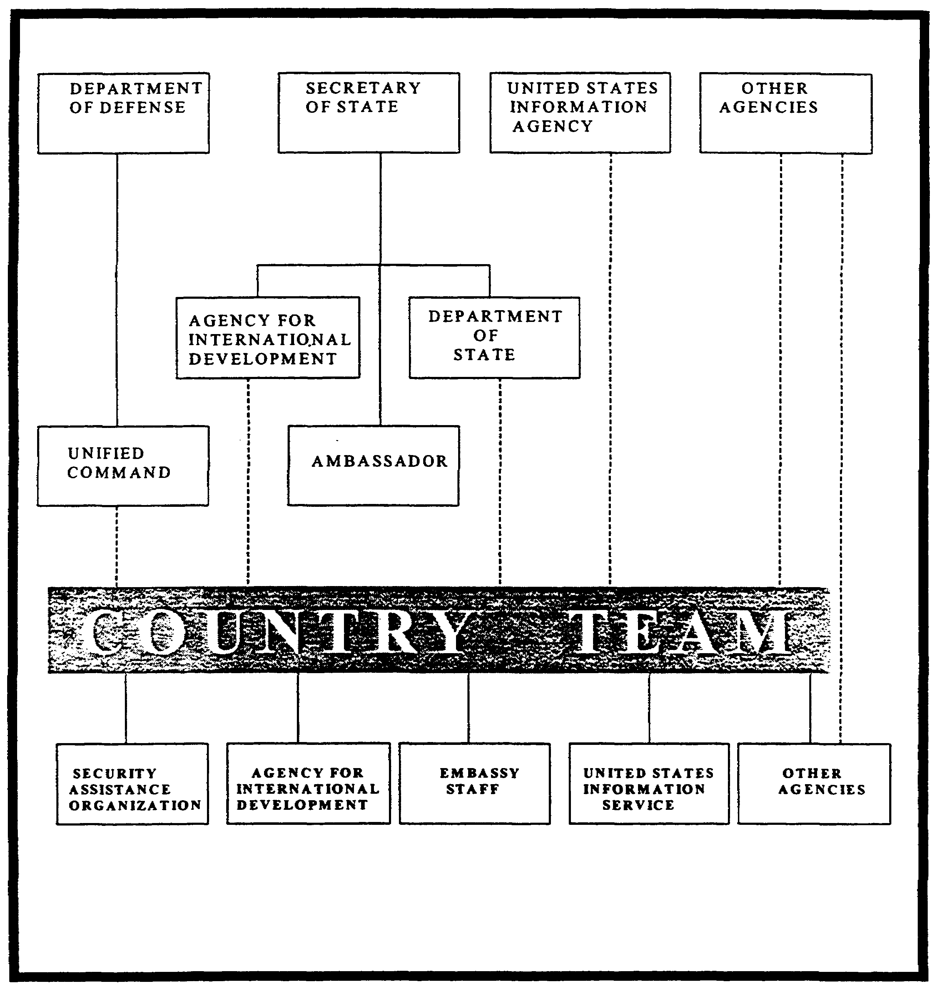

Figure 1-4. The Country Team Concept

1-23 IT0480
LESSON 1

PRACTICE EXERCISE

The following items will test your grasp of the material covered in this lesson. There is only one correct answer for each item. When you have completed the exercise, check your answers with the answer key that follows. If you answer any item incorrectly, study again that part of the lesson which contains the portion involved.

1. What is an insurgent?

A. Citizens who protest US military combat personnel entering their country.

B. Citizens attempting to legally alter the governmental structure by holding private elections.

C. Citizens of a country attempting by illegal means to change the way it is governed.

D. People that privately disagree with the government over political issues and hold meetings to discuss how to rectify identified shortcomings.

2. What is a governmental takeover by a relatively small group within a nation called?

A. Insurrection.

B. Rebellion.

C. Insurgency.

D. Coup d'etat

3. What is host country IDAD strategy based one?

A. Preventing insurgent movements.

B. Intelligence requirements pertinent to PSYOP.

C. Recruiting as many individuals as possible.

D. Guidance for the collection of intelligence.

IT0480 1-24
4. What is the responsibility of the national-level organization?

A. To establish area coordination centers at the state and local levels.

B. To help the coordination centers at all levels to gain popular support.

C. To counteract an insurgency.

D. To be concerned with the overall threat to the nation and total resources available for employment in IDAD.

5. Which of the following components is not a dependent component of IDAD strategy?

A. Balanced development.

B. Mobilization.

C. Intelligence operations.

D. Security.

1-25 IT0480
LESSON 1

PRACTICE EXERCISE

ANSWER KEY AND FEEDBACK

Item Correct Answer and Feedback

1. C. Insurgents are citizens of a country attempting by illegal means to change the way it is governed. (page 1-2)

2. D. Coup d'etat is a governmental takeover by a relatively small group within a nation. (page 1-2)

3. A. Host country IDAD doctrine is designed to prevent insurgent movements. (page 1-12)

4. D. The national-level organization is concerned with the overall threat to the nation and total resources available for employment in IDAD. (page 1-12)

5. C. The four dependent components of IDAD strategy are balanced development, security, neutralization, and mobilization. (page 1-12)

IT0480 1-26
LESSON 2

STABILITY AND SUPPORT OPERATIONS

CRITICAL TASK: 301-336-3604

OVERVIEW

LESSON DESCRIPTION: In this lesson you will learn about:

- Internal defense and internal development (IDAD).
- The nature and direction of IDAD.
- The three components of IDAD strategy.
- How the U.S. conducts Stability and Support Operations (SASO).
- The concepts, tasks, emphasis, and factors involved in IDAD planning.

TERMINAL LEARNING OBJECTIVE:

TASK: Describe stability and support (S&SO) operations.

CONDITION: You will be given narrative information from FM 34-3, and FM 100-20.

STANDARD: You will describe foreign internal defense operations in accordance with FM 34-3, and FM 100-20.

REFERENCES: The material contained within this lesson was derived from the following publications:

FM 34-3
FM 100-20
FM 100-23

INTRODUCTION

The nature of insurgency dictates the methods by which it must be opposed. Military operations designed for war cannot succeed in counterinsurgency. Conventional tactics will exhaust the government's forces and provoke the people because of harm to their lives and property. Government violence usually only strengthens the insurgents' cause by bolstering numbers of new recruits and support. A governments counterinsurgency program must be more effective in mobilizing internal support than the insurgents. To reach success, a government must utilize the same principles embodied in Stability and Support operations. The government must develop political, social, and economic strategies while ensuring that the military forces exemplify the governments legitimacy and competence.

Stability and support operations (SASO) are a type of IDAD assistance provided by US Armed forces to maintain, restore, or establish a climate of order within which the legitimate government can function effectively. SASO often take place in environments less well defined than in war.

2-1 IT0480
The identity of belligerent or insurgents may be uncertain and the relationship between a specific operation and a campaign plan may be more difficult to define than would normally be the case in war. US forces involved in SASO may not encounter large, professional armies of even organized groups responding to a chain of command. Instead, they may have to deal with loosely organized factions or irregulars, terrorists, or other conflicting segments of the population as predominant forces. These elements, as discussed in Lesson 1, will attempt to capitalize on perceptions of dissatisfaction or disaffection within the population. Criminal syndicates may also be involved.

The US Army intelligence operations, combined with those of the host country should be considered as soon as US military assistance is committed. Intelligence operations are of critical importance in the early phases of the insurgency to identify and neutralize personnel key to the insurgency infrastructure. Intelligence analysts also contribute to a data base from which SASO operations can logically formulate. The close link desired by such elements and the majority of the civilian population means the traditional elements of combat power, such as massive firepower, may not apply to peace operations. The nonviolent application of military capabilities, such as civil-military information and PSYOP may be more important.

PART A: II. ARMY SUPPORT OF STABILITY AND SUPPORT OPERATIONS

An explanation of how the Army and intelligence personnel become involved in IDAD operations is necessary to provide a complete understanding of IDAD operations doctrine.

Stability Operations. Stability operations apply military power to influence the political environment, facilitate diplomacy, and disrupt specified illegal activities. They include both developmental and corrective actions. Forces conduct stability operations to accomplish one or more of the following:

- Deter or thwart aggression.
- Reassure allies, friendly governments, and agencies.
- Stabilize a restless area
- Encourage a weak or faltering government.
- Maintain and restore order.
- Enforce agreements and policies.

While each operation is unique, seven broad imperatives help forces develop concepts and schemes for executing stability operations. These imperatives form the basis for analytical support to the commander during stability operations.

- Stress force protection.
- Emphasize information operations.
- Maximize interagency, joint, and multinational cooperation.

IT0480 2-2
- Apply force selectively and discriminately.
- Display the capability to apply force without threatening.
- Understand the potential for disproportionate consequences of individual and small unit actions.
- Act decisively to prevent escalation.

Support Operations. Support operations provide essential supplies and services to assist designated groups. They are conducted mainly to relieve suffering and assist civil authorities respond to crises. Support operations are normally characterized by lack of an active opponent. In most cases, Army forces achieve success by overcoming conditions created by man-made or natural disasters. The ultimate goal of support operations is to meet the immediate needs of designated groups and transfer of responsibility quickly and efficiently to appropriate civilian authorities. Support operations which consist of humanitarian assistance and environmental assistance, accomplish one or more of the following:

- Save lives.
- Reduce suffering.
- Improve quality of life.
- Recover essential infrastructure.
- Restore situations to normal.

While each operation is unique, seven broad imperatives help forces develop concepts and schemes for executing support operations. These imperatives form the basis for analytical support to the commander during support operations:

- Secure the force.
- Provide essential support to the largest number of people.
- Coordinate actions with other agencies.
- Conduct robust information operations.
- Hand over to civilian agencies as soon as feasible.
- Establish measures of success.
- Ensure operations conform to legal requirements.

Stability and support operations present unique challenges to the military planner. This process is a proven tool for analysis of force-on-force situations of war and open conflict. However, the analytical categories of METT-TC (Mission, Enemy, Terrain, Troops, Time, and Civilian considerations) are inadequate to deal with the intricacies and complexity of most SASO.

2-3 IT0480
In-depth knowledge of a nation's or region's history, politics, culture, and society, in addition to its military capabilities, is key to understanding how to plan and conduct effective military operations in support of U.S. national policy. The SASO model provides a framework for the planner to analyze all types of SASO situations, from Non-combatant Evacuations to Disaster Assistance. The model assists in organizing information and determining its significance to possible U.S. military operations. This provides a basis for the development of course of action (COA). The SASO Analysis Model is intended to be useful at all levels: tactical, operational, and strategic. Its information and evaluations are useful for planners at all levels.

The model assumes a national level analysis of the situation has been done and a decision has been made or is anticipated to seriously consider employment of the military instrument of power. The analyst must have an appreciation of the pertinent U.S. national interests, as well as the current security situation and current planning factors.

Intelligence operations are of critical importance in the early phases of insurgency to identify and neutralize the insurgent infrastructure (political leadership) and to develop an intelligence data base. Analysis of this database should produce a more accurate picture of the degree of insurgent control in different areas of the country. This analysis will also provide a foundation from which logical SASO operations can be formulated. It is particularly important to coordinate all functional elements of the plan so that available personnel and materiel resources will be used properly. The Army operations annex has appendixes with topical headings which generally follow the six roles of the military discussed in Lesson 1. One of these appendixes relates to intelligence. It states the intelligence assets and measures to collect, process, and disseminate intelligence concerning the insurgent, weather, terrain, and population. It also prescribes the counterintelligence activities necessary to minimize insurgent espionage, subversion, and sabotage. The intelligence appendix must include intelligence requirements and information pertinent to PSYOP, civil affairs, communications security (COMSEC) monitoring, and support.

The US Army provides personnel, units, and administrative personnel to security assistance organization (SAO) as directed by the department of defense. The SAO is a military agency present in a host country to advise that country and to administer the security assistance program for the US department of defense. As stated in Lesson 1, the commanders of unified commands and the chiefs of SAOs use US Army Forces to support SASO operations. These US elements advise and train host country armed forces.

The security assistance force (SAF) is a composite of units organized under a special forces group headquarters. The organization is based on the requirements of the supported command and is structured on the concept of employing mobile training teams and small detachments to fulfill specific mission requests. The flexibility and wide range of skills available in a SAF provide the Army with a force to temporarily augment the SAOs capability for SASO.

Theater based backup forces consists of elements from all Army branches, besides essential support units, and are an augmentation to the SAF. Generally, it is committed when requested by the SAO if the capabilities of the SAF have been surpassed by the host country requirements.

CONUS-based general purpose forces are used for further augmentation when necessary. In consonance with contingency planning, area-oriented forces may be trained for SASO and designated for employment in specific areas of the world. The Army's SASO role provides for intelligence and security support to deployed forces. Combined US and host country military

IT0480 2-4
intelligence operations facilitate the quick establishment of effective collection and production capabilities.

PART B - BASIC AND CURRENT INTELLIGENCE

A vital and continuing requirement in SASO operations planning is basic and current intelligence. The documentary database and day-to-day warning data are the basic instruments used in planning SASO.

Documentary Data Base.

The first intelligence requirement in SASO planning is a detailed, comprehensive, and up-to-date intelligence documentary database covering all countries of the world considered susceptible to insurgency. This documentary database is essential for long-and short-range contingency planning and for the training and use of personnel and units assigned readiness responsibilities on a geographical basis. Collection of basic intelligence data should begin long before US forces are deployed.

The intelligence data base must include the following six categories of detailed intelligence regarding host countries:

- Political.
- Economic.
- Sociological.
- Geographic.
- Military.
- Insurgent.

These categories should be covered in detail at national, regional, and local levels. The requirement for detail is of considerable importance if we are to project proper training and contingency planning. Included in the database is documentary intelligence on such subjects as the background of the insurgency, its known leadership, extent of development, actual or potential strengths and weaknesses, internal organization, and support (whether it is internal or external).

The Army relies heavily on external agencies for the documentary database it requires. Estimates, surveys, studies, area handbooks, and other publications produced by government agencies, and private publications (such as 'National Geographic Magazine') can contribute to, or provide the foundation for, the database.

A statement of intelligence interest is one method used in obtaining this necessary data The statement of intelligence (SII) is a standing request for dissemination of the full range of intelligence produced by the entire intelligence community.

2-5 IT0480
Day-to-Day Warning Data.

Besides the documentary database, a requirement exists for timely, accurate, and current intelligence for day-to-day monitoring of the extent of subversive activities and the development of insurgencies. Such warning data is essential for the refinement of contingency plans, the reorientation of training, and the initiation of preliminary operational requirements. Current intelligence must provide detailed coverage on the most recent, significant developments in areas of concern regarding the six categories of intelligence mentioned previously. Current intelligence when combined with the documentary database will provide an operational database. Spot reports, routine, daily, and weekly summaries, and other special reports received from national agencies provide the major input to current intelligence holdings. Appropriate collection agencies must fill gaps in intelligence holdings.

PART C - COORDINATION CENTERS

Intelligence units must coordinate their activities closely with the coordination center organizations to eliminate duplication of effort and to insure that intelligence requirements are met. The two organizations that provide direction and a unified IDAD effort are:

The National Planning and Coordination Center (NPCC). The NPCC is the highest level organization concerned with planning and coordinating operations and is responsible to the host nation's chief executive. A director heads this department and supervises the activities of the major staff offices which comprise an NPCC. It provides national level, centralized direction to planning and conducting SASO operations. Staff offices are responsible for formulating the plans which will become part of a national plan. Figure 2-1 depicts a type of NPCC and its subordinate staff functions. US advisors are normally assigned to various posts within the NPCC. The extent of their advice depends on US/host country agreements. Success often depends on the personalities of the advisors assigned to these critical posts.

Coordination Center (ACC). The ACC is responsible for planning, coordinating, and exercising operational control over military forces and governmental civilian organizations at regional, state, or local levels. US/host country agreements will again govern the command relationship between combined forces in their respective ACC areas of jurisdiction. A senior government official heads the ACC, supervising and coordinating the activities of the military forces and official civilian agencies operating within the center's jurisdiction. An ACC will normally be staffed by members from the area military command, police, intelligence organization, public information and PSYOP agencies, paramilitary forces, and other local and national government offices involved in economic, social, and political endeavors.

The intelligence advisor at both levels is responsible for the development of programs, concepts, and plans, and provides general guidance on intelligence related to national security. He also coordinates intelligence activities, correlates, evaluates, and interprets intelligence relating to national security and disseminates intelligence.

IT0480 2-6
PART D - TACTICAL PLANNING AND COLLECTION

The combined US and host country tactical planning is the key to progress in the development of in-country intelligence capabilities. Care must be taken to see that the intelligence and security resources of both countries are employed effectively and efficiently. Planning for a collection effort must be well organized and managed to take advantage of all available intelligence resources. Figure 2-1 depicts a type of counterinsurgency planning and coordination organization that may be established at the national level.

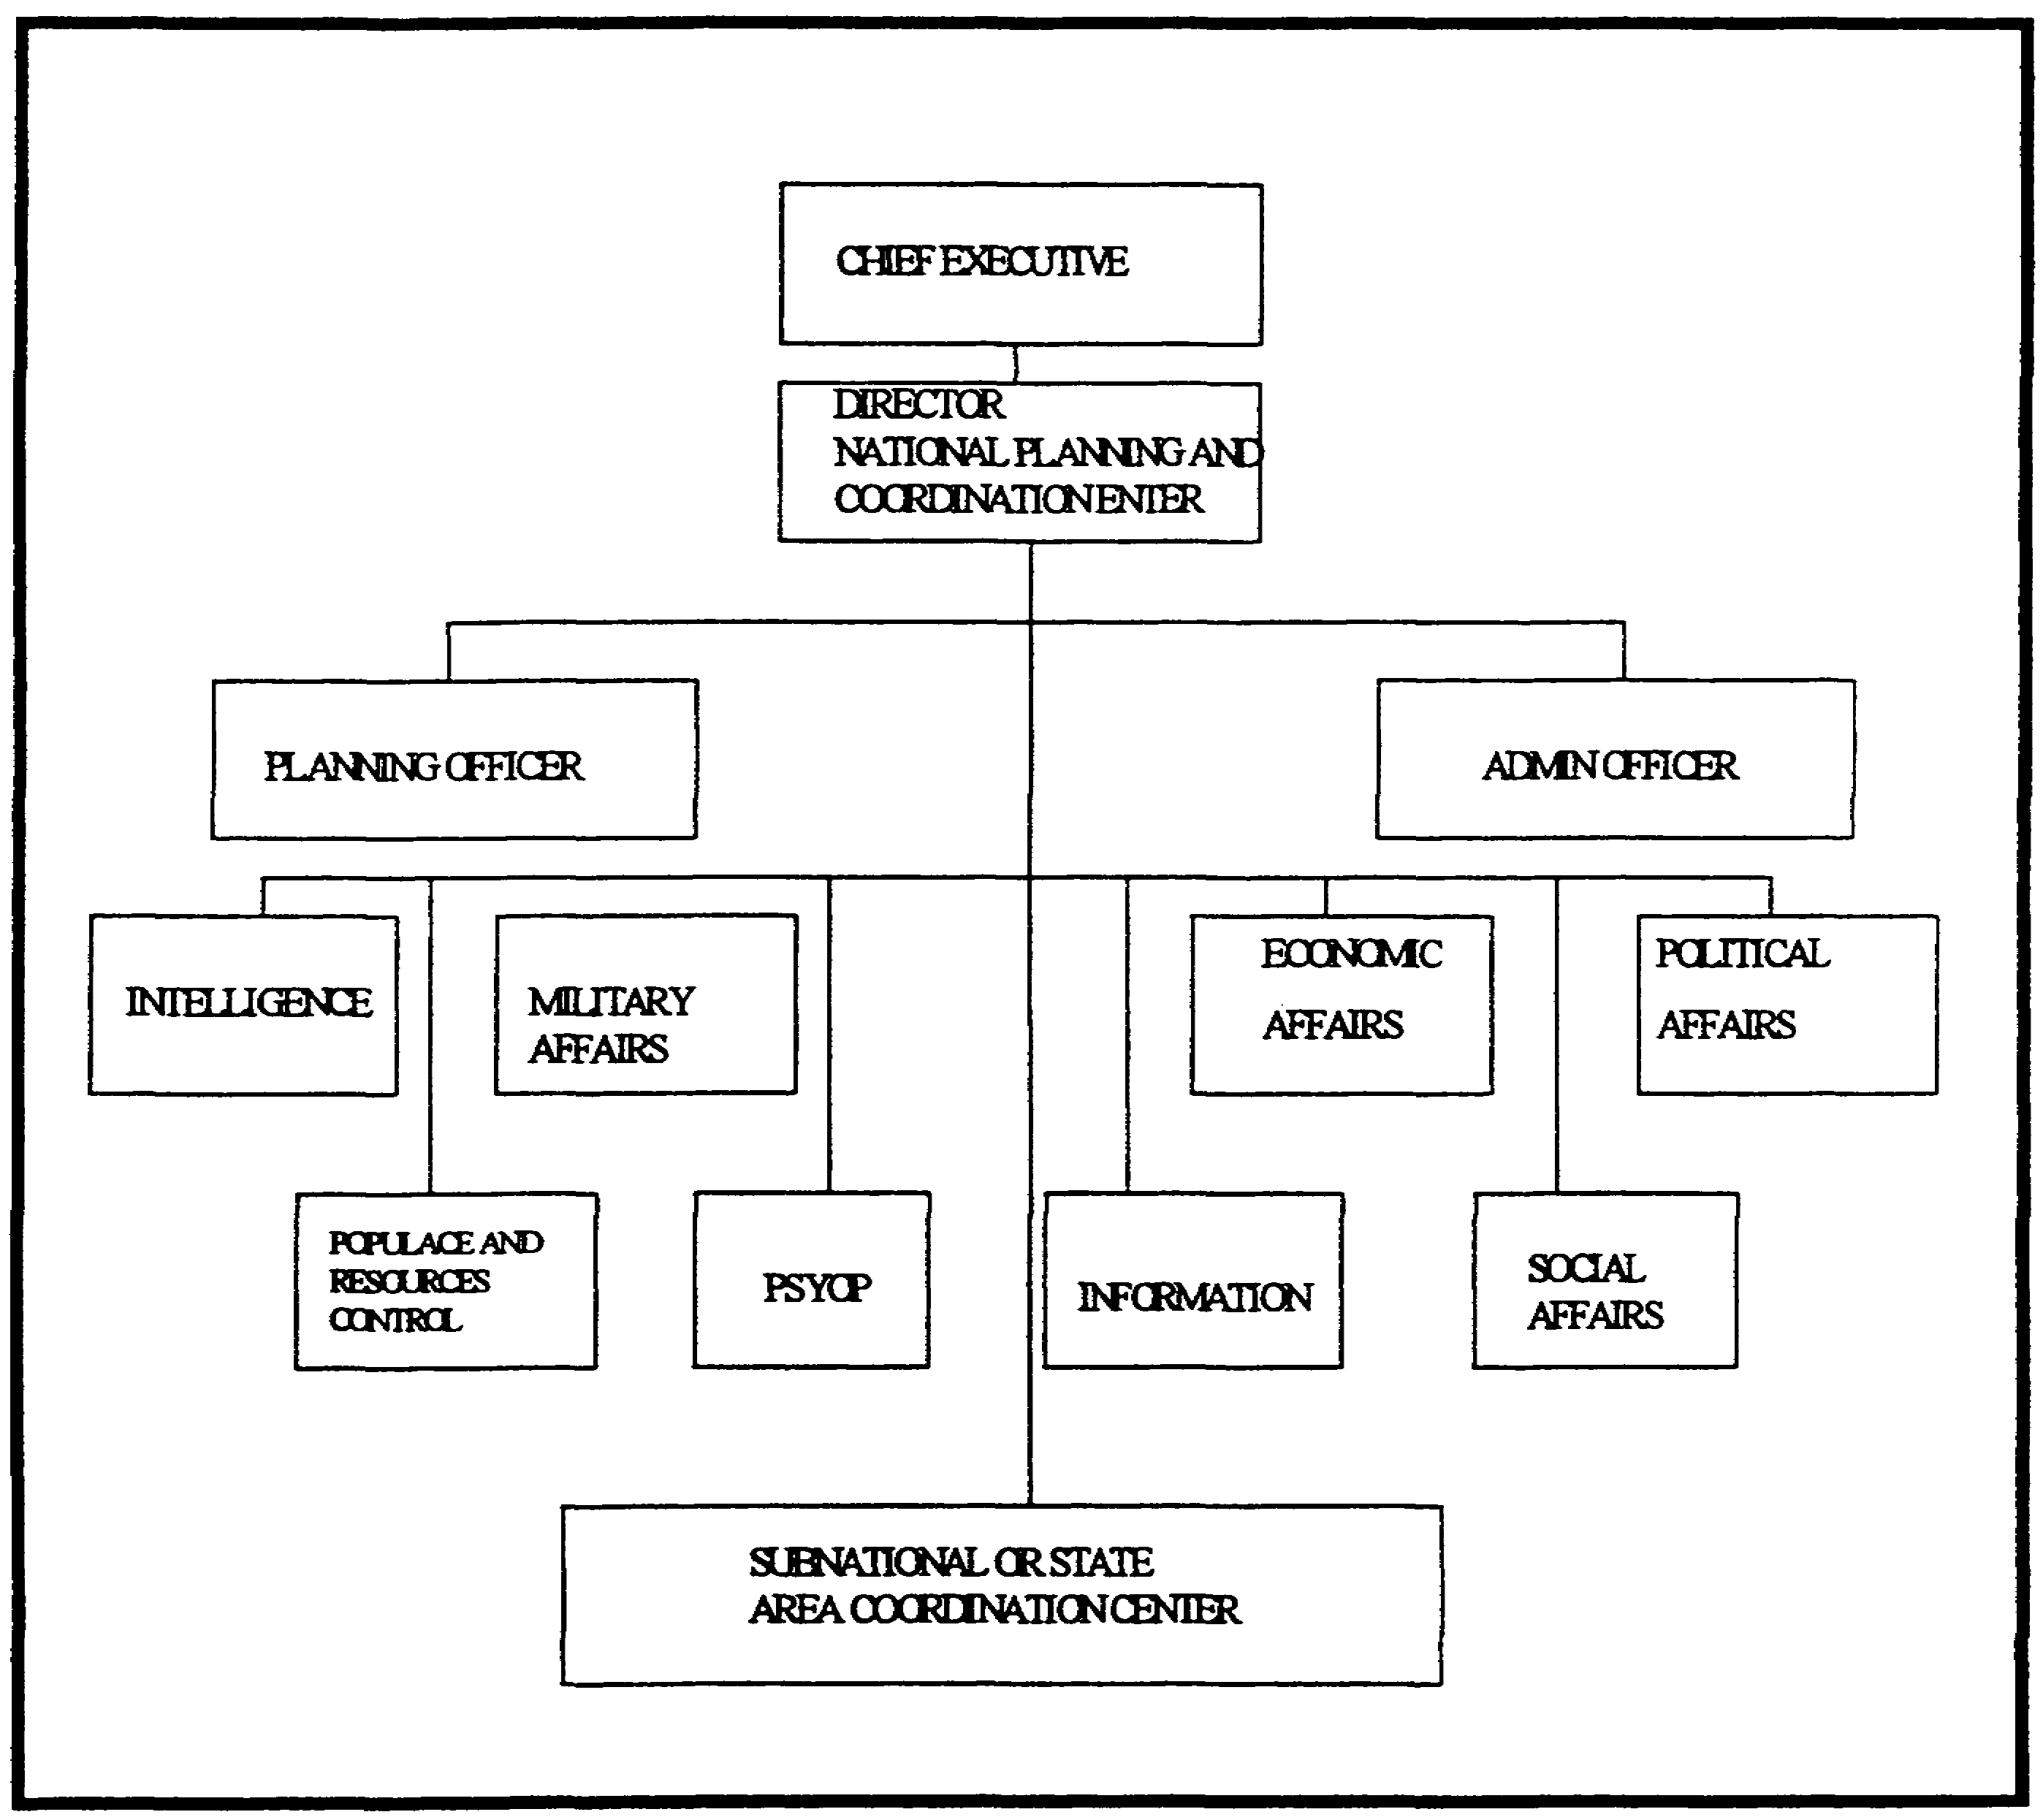

Figure 2-1. Counterinsurgency Planning and Coordination Organization

Generally, US Army intelligence operations should be initiated as soon as an advisory effort is committed to a country threatened by insurgency. Intelligence participation should extend through

2-7 IT0480
the entire spectrum of intelligence production and collection activities. It is basic doctrine that US intelligence operations will be channeled primarily through the host country structure.

In conventional military operations, intelligence staffs assess the objective factors of enemy, weather, and terrain. The intelligence needs for IDAD operations are based on broader considerations of the insurgent situation and must place greater emphasis on the population. The population is both the primary target of the insurgent and a principal source of his intelligence cover, personnel, and logistical support. Additionally, detailed intelligence concerning sociological, political, geographic, and economic information will have significant impact on operations. These requirements must be given the same consideration as the usual tactical requirements mentioned above.

In planning a collection effort, information is needed not only about the armed insurgents, but also about their underground organization and their relations with the populace. To efficiently execute and supervise the collection effort, the intelligence officer must thoroughly understand:

- IDAD mission.
- Area of operations.
- Nature of the available sources of information.
- Capabilities and limitations of available agencies.
- Steps in planning and executing the collection effort.
- Tactics, organization, and characteristics of the enemy intelligence and surveillance capability.
- Characteristics of the local populace, including political loyalties, religion, economic systems, and social customs.

A collection plan (See Figure 2-2) assists the intelligence officer in the coordination and integration of the collection efforts. Collection planning is essentially a mental process. The written plan format, however, acts as a management tool and is less subject to error. It helps to ensure that the commanders information requirements are satisfied. A collection plan should include at least the following elements:

- A list of priority intelligence requirements (PIR) and information requirements (IR) usually stated in question form.
- The indicators pertinent to each PIR/IR.
- The specific information requirements sought in connection with each information.
- The collection agencies to be used in obtaining the information.
- The place and time of the reported information. A remarks column to indicate the progress of the collection effort.

IT0480 2-8
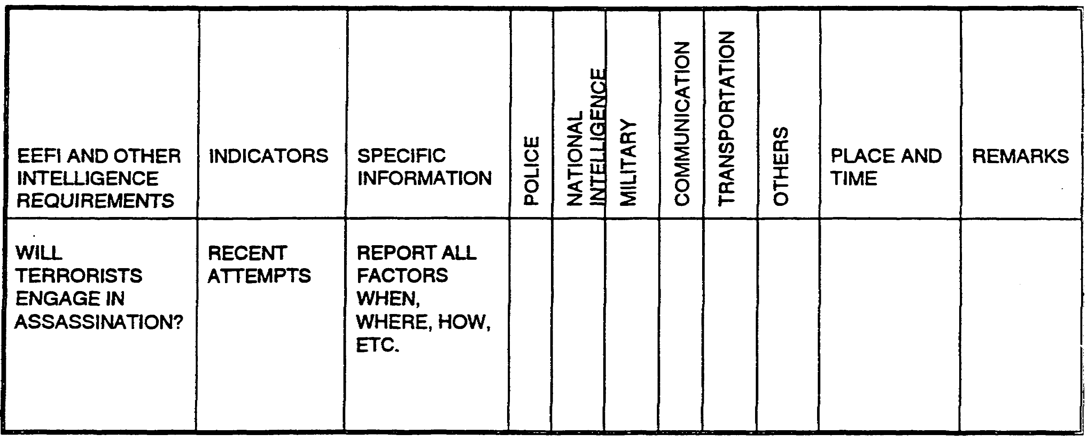

Figure 2-2. A Sample Format of a Collection Plan.

An intelligence priority system ensures that the most effective use is made of the collection methods available. The highest priority items are those considered to be critical to mission accomplishment. Other intelligence or information requirements are items of significant interest, but not considered critical.

Active supervision of the collection effort by the intelligence officer is necessary to ensure its success. Overall supervision is best achieved by conducting periodic visits to the collection agencies. When developing a collection plan for IDAD operations, it must be kept in mind that those intelligence needs are based on broader considerations of the insurgent situation and the operational environment. Valid intelligence requirements are those based on these two variables: information needed to fill gaps in current holdings, and intelligence needed to plan tactical operations against the insurgents. IDAD operations offer a wider variety of sources of information and agencies than a conventional situation. The collection effort should reflect the flexibility these additional sources and agencies provide. Almost all host country government agencies, from public health to communications, can collect information.

One significant variation to the overall collection program and the selection of collection agencies in IDAD operations is the heavy reliance on police, security, and counterintelligence agencies. During the initial phase of the insurgency, the police department is the best collection agency. This is because local police are most familiar with criminal elements, significant personalities, and the general populace in their respective areas. In conjunction with their mission to penetrate the insurgent infrastructure and maintain area coverage-type information nets, they can also develop information of potential

2-9 IT0480
intelligence value in the political, economic, and sociological areas. Orders and requests for specific information are based on indicators of enemy activity. Collection agencies are directed or requested to supply information which will confirm or deny the indicators. Emphasis should be placed on the value of negative reports, since a lack of enemy activity may be a significant indication of the insurgent's course of action in a particular area or a shifting of emphasis to another area.

A single item of information received in response to orders and request may appear unrelated to other reports received or insignificant by itself. The intelligence officer must map and chronologically record this information over a long period of time. This may lead to a definitive and predictable pattern of enemy activity. This process, called pattern analysis, answers two basic questions:

- Where is the enemy expected to be found?
- What are the enemy's most probable courses of action?

The intelligence estimate of the insurgency situation is based on all available intelligence. It considers everything of operational significance (such as assessment of the situation, assumptions concerning enemy actions, and dissemination of information). One of the most important aspects of intelligence operations in this environment is the detection and exploitation of the vulnerabilities inherent in insurgent forces. The intelligence officer in that region must develop details of insurgent weaknesses for a specific area.

PART E - COUNTERINTELLIGENCE SUPPORT

Since IDAD operations are aimed basically at the restoration of internal security in the AOs, they demand a vigorous and coordinated counterintelligence (CI) effort. Liaison between military and civilian CI agencies, and other related activities is essential to successful CI efforts. Many CI efforts are defensive in nature, aimed at the protection of installations against sabotage, personnel against espionage and subversion, and information against compromise. Some of these efforts are:

- Maintenance of files on organizations, locations, and individuals of CI interest.
- Background investigations and records checks on persons in sensitive positions and those whose loyalty is questionable.
- Indoctrination of personnel in security.
- Inspection of the internal security of installations and units.
- Population control measures including identification systems, travel restrictions, and coordination of search procedures in the installation.
- Raids on suspected insurgent meeting places including cordon operations.
- Coordination of censorship activities.
- Debriefing of selected personnel including combat patrols, aircraft pilots, hostile personnel, and other elements who have information of CI interest.

IT0480 2-10
- Coordination with military police (MP) elements concerning control of black-market activities which could aid the insurgent forces.
- Investigation of terrorist and sabotage incidents in an attempt to identify terrorists and saboteurs.

Counterintelligence operations must place emphasis on offensive operations against the insurgent infrastructure so it can be identified and neutralized. The heavy reliance placed upon police, security, and host country CI agencies is a significant variation to the overall collection program in IDAD operations. The basic responsibilities of CI elements and personnel in IDAD operations are the denial of intelligence information to the insurgent force, and the identification and neutralization of the insurgent infrastructure. Counterintelligence operations encompass CI investigations and services. The CI investigations include specific investigations of individuals or incidents through personnel security investigations and the complaint-type investigation. The services entail specific security services provided to assist commanders in planning, implementing, and maintaining adequate safeguards against sabotage, espionage, and subversion. Detailed information must be collected concerning the insurgent intelligence apparatus. This information provides the basis for CI planning and conducting an effective security program.

The success of a security program will depend upon how efficiently the following activities have been accomplished:

- Denial of information to the insurgents through proper security controls and procedures.
- Formulating and planning security training programs.
- Detection, investigation, and elimination of security breaches and weaknesses.
- Detection, identification, and neutralization of hostile intelligence activities.
- Monitoring the populace to reduce threats to host country security.

Host country police agencies can provide valuable information to intelligence officers. In conducting their investigations, the police may be the first government agency to detect evidence of an insurgency.

PART F - COMBAT SURVEILLANCE SUPPORT

Combat surveillance is the all-weather, day, and night, systematic observation of the battle area for intelligence purposes. In planning surveillance operations, the factors of mission, enemy, terrain, weather, time, and troops available govern the organization and disposition of forces. Because surveillance is systematic and continuous, units conducting these operations normally commit the bulk of their forces to observation, while retaining a small reserve force to assist elements that may be attacked by the enemy. Doctrine for combat surveillance in IDAD operations is basically the same as in other types of warfare; however, the scope is broader. Combat surveillance in the internal defense environment is extended over an entire area of interest. Combat surveillance is a principal means by which the intelligence officer implements his collection plan to provide for detection of general plans and coordinates surveillance activity with the operations officer and other collection agencies, and consults with appropriate members of the staff to ensure coordination of surveillance with other

2-11 IT0480
activities. This additional coordination for IDAD operations includes fire support coordinator personnel, host country civilian, paramilitary, and military personnel, and other US military and civilian organizations and agencies in-country.

Detection of enemy activity is especially difficult in an insurgent environment. The enemy's ability to blend with the local populace dictates that surveillance techniques employed vary with the degree of loyalty of the people to the government and with the degree of insurgent pressure in the area. Valuable information is derived from watching the actions and attitudes of the people. Any observed variation from their normal pattern of living, their willingness to cooperate, the presence or absence of children and young men in a village, or the presence of people in areas not normally inhabited should serve as an indicator of insurgent presence in that locale.

Insurgency can be detected through direct and indirect evidence. Direct evidence, such as easily identified uniforms, equipment, and deliberate field fortifications, is normally difficult to gather in IDAD operations. Probably the first indication of insurgent presence will be furnished by indirect evidence. Some indicators are:

- Ostensible civilian activity in isolated areas or areas where activity normally has not been observed.
- Isolated areas being prepared for food crops, or small areas of forest being cleared of underbrush and thick foliage for no apparent reason.
- Unexplained movement of local inhabitants from one location to another.
- Roads, cart trails, and footpaths that are inconsistent with the population and agricultural practices of the area.
- Other unexplained disturbances to the normal vegetation cover in the area.
- Fires in remote areas not caused by local ground-clearing operations or indigenous cultivation.
- Fishnets located in isolated areas or areas previously not fished.
- Abnormal traffic on established roads and waterways.
- Unexplained increase in dwelling density of villages.
- Unidentified suspicious activity detected by infrared or other sensory devices.

Combat surveillance is required through all phases of an insurgency. The requirements differ at each level according to the phase of insurgency involved.

PART G - GROUND SURVEILLANCE

Ground surveillance integrates all available means of human and mechanical surveillance to cover an area of interest. Mechanical devices are employed to take advantage of their all-weather, day and night capability. Ground surveillance is characterized by line-of-sight limitations, dependence on terrain for movement and site locations, and a limited capability of surface transport to displace surveillance

IT0480 2-12
means in time to be responsive to immediate requirements. Units performing ground surveillance missions provide current information by detecting, locating, identifying, and reporting information of military significance.

Ground surveillance is part of the mission of all combat units and is accomplished as part of the normal unit standing operating procedures (SOP), or as a result of the commander's specific intelligence needs.

Equipment Resources.

Ground surveillance is performed mainly by visual observation and patrolling, especially during periods of reduced visibility. Special sensors and mechanical devices, such as ground surveillance radars, anti-intrusion devices, remote sensors, night vision scopes, and searchlights often complement this effort. All this equipment, however, has certain limitations, the most common being the requirement for ground line-of-sight.

Human Resources.

Ground surveillance plans require the coordination and employment of all available surveillance means, but most of the emphasis is on human resources. The use of combat patrols is of paramount importance in IDAD operations. Regardless of the type of patrol or mission assigned, the collection and reporting of intelligence is a continuing responsibility for all patrols Combat patrols should be trained to observe and report both negative and positive evidence of past or present enemy activity including:

- Newly developed trails.
- Vacated assembly areas.
- Locations of fortified and booby-trapped areas.
- Cache sites, whether active or not.
- Location of potential landing and drop zones.

Patrol training should place emphasis on:

- Detection and attack of enemy ambushes.
- Detection and disarming of booby-traps.
- Knowledge of insurgent delaying devices.
- Knowledge of enemy deception practices.
- Current effects of weather on terrain.
- Trafficability.
- Tracking techniques.
- Procedures for calling for fire support.

2-13 IT0480
Patrolling in IDAD operations involves much more than just looking for the enemy. It also involves making contact with the people who inhabit the area of interest. Patrols should be required to contact local police, village chiefs, and friendly paramilitary units as part of their missions. They must be able to observe and report on those items of intelligence interest listed above. Contact with civilians may require that patrols include linguists. When available, qualified US military linguists can be used; however, this type of personnel will not usually be available for everyday operations. In that case, maximum use should be made of host country soldiers who are proficient in the English language and who have been fully cross-trained in all aspects of insurgent patrolling procedures.

Long-Range Surveillance Operations (LRSO). LRSO operating under the staff supervision of the intelligence staff section, make important contributions to the ground surveillance and reconnaissance plan by reporting information concerning remote portions of the area of interest. Terrain inaccessible to other target acquisition means can be exploited to some degree by LRSO. Indigenous LRSO, clothed and armed like the insurgents, can be dispatched to work close to, or among, insurgent troops. Indigenous LRSO are requested on a support or attachment basis to ensure they are under the operational control of the commander requesting them. Long-range reconnaissance patrol units should begin operating in the initial phase of the insurgency. The number of LRSO should be increased as necessary in future operations to satisfy requirements of US major tactical units.

Other Sources. Other intelligence sources assist in gathering information for future requirements, and make available intelligence, already in their possession, which may be of military value. These other sources include:

- Counterintelligence units which provide a good source of contact with local civilians and investigate suspicious activity that occurs both in military areas and civilian communities. They also maintain files on people and organizations that may serve as further contacts for ground reconnaissance elements.

- Agent operations provide a source of information from within the enemy area. Often agents penetrate an area and gather information not otherwise available through any form of overt action.

- Interrogation of prisoners, suspects, defectors, and refugees can produce new intelligence and assist in confirming or refuting information gathered from other sources.

- Stay-behind units can establish and maintain contact with insurgent forces and furnish scheduled reports of their activities. Stay-behind units are capable of remaining in contact for long periods of time, and the information they furnish has a very high degree of reliability.

- Technical intelligence specialists and document translators offer valuable intelligence gathered from captured documents and materiel. Many items brought back by reconnaissance patrols will furnish additional intelligence once it has been identified and analyzed by these specialists.

- US returnees can provide valid intelligence when properly debriefed by intelligence personnel. The fact that returnees have been trained to observe and retain information of intelligence value, and have physically passed through insurgent territory, makes them an excellent source.

IT0480 2-14
- Communications intelligence (COMINT) resources can provide a valuable source of intelligence through the interception, decoding and analysis of enemy communications. COMINT provides for continuous all-weather, day and night surveillance operation of the insurgent communication network.

- There are other specialized organizations that can provide assistance in gathering intelligence. While their primary mission is not intelligence, the nature of their operations places them in a position to obtain valuable information. Some of these organizations are special forces units, US aid missions, and host government.

- Special forces units are strategically located within a host country such as adjacent to border crossings and near suspected insurgent areas of operation. They can also be found within or near civilian occupied areas. They are in constant contact with the terrain and populace, and are involved in operations directed against the insurgent forces of the area.

- US aid missions provide assistance to the indigenous personnel of an area. Because their people travel around the country, their reference material and contacts can provide a vast amount of useful information.

- Host government has many of its own sources for gathering intelligence. The most important are those that extend through all echelons of the government structure. The major organizations in this category include host country military and paramilitary forces, civilian police, local governmental organizations, and religious groups.

PART H - AERIAL SURVEILLANCE

Aerial surveillance extends the Army's capability to perform surveillance operations over large areas and beyond the ground line-of-sight limitations imposed on both the human eyes and ground sensor equipment. The adverse effects of distance, mountainous terrain, dense jungle, poor weather, and poor illumination are reduced or eliminated. Aerial surveillance should be used as early as possible in the initial phase of the insurgency and continued throughout all phases. The success of aerial surveillance in SASO operations depends on the environment and the individual's adjustment to it. The nature of insurgent forces is that they are difficult to detect or identify because of their organizational structure, practices, and tactics. The apparent lack of insurgent air defense systems allows greater operational flexibility for aerial surveillance aircraft. The difficulty of detecting enemy locations is balanced by control of the air space. The tactical air surveillance officer's liaison and coordination responsibilities parallel those used for ground surveillance. However, maximum use must be made of comparative cover by integration of all sensor modes available, such as:

- Vertical imagery.

- Color and camouflage detection imagery.

- Visual observation.

- Infrared.

- Unmanned Aerial Vehicle (UAV).

2-15 IT0480
Employment of sensors to detect enemy activity must be based on a thorough knowledge and analysis of all available intelligence information. The considerations in planning and employing aerial surveillance for conventional warfare remain valid for SASO operations. The following amplification of methods and techniques is provided:

- Visual Aerial Surveillance. By assigning pilots and observers to the same area on a daily basis, they become intimately familiar with the topography and activity in that area. This facility recognition of any changes which may indicate enemy presence. The use of "low and slow" aircraft gives a closer view of the terrain for a longer period of time and is considered the most suitable for this type of observation. A special technique of visual aerial surveillance is the use of continuous day and night visual observation missions over friendly installations, and beyond the maximum effective range of the weapons available to the insurgent. The insurgent's use of mortars, rockets, and crew-served weapons, necessitates his stockpiling of ammunition and preparation of firing positions prior to an attack. This activity can be detected using day and night visual aerial surveillance.

- Permanent Record Imagery. The hand-held camera provides an effective supplement to other aerial imagery by providing quick reaction photography of visual sightings. This capability is enhanced by the use of self-developing film. The general rule for photographic imagery is that the scale of coverage be as large as possible, consistent with the type of coverage desired and the needed urgency of the information.

Unlike photography or visual sightings, radar imagery will record friendly, neutral, and hostile indicators with equal discrimination. Radar surveillance should be used only when insurgent movement is expected to be heavy enough to be detected. This is done by targeting areas generally restricted to enemy occupation or during curfew hours established by the host country government.

Infrared Imagery and Photography. These two are complementary and should be used together for best results. Infrared coverage detects patterns of relative temperature emissions in a suspected area. However, the intensity can be reduced by dense overhead canopy.

PART I - INTELLIGENCE PROCESSING

Processing is that phase of the intelligence cycle where previously collected data becomes intelligence. The four operations involved in processing are: recording, evaluation, interrogation, and interpretation.

- Recording of the reduced data by writing, mechanical, or electronic means.

- Evaluation of the reduced data as to pertinence, reliability, and accuracy.

- Integration is the result of making deductions, as to the probable meaning of new information and determining its implication with respect to future insurgent activity.

- Recording. The extent of the recording effort will depend to a large degree on the insurgent activity in the area and the personnel available to maintain and analyze the recorded information. Three

IT0480 2-16
aids which apply generally to the recording process are the intelligence journal, the journal file, and the intelligence workbook.

The intelligence journal is a permanent, chronological record of reports and messages that have been received and transmitted, of important events that have occurred, and of actions taken in response, covering a specific period of time, usually 24 hours. The journal file contains record copies of all messages and documents noted in the journal. It supports the intelligence journal and is a permanent official record. The intelligence workbook is a systematic arrangement, by subject heading, which aids in the sorting, evaluation, and interpretation of information, and in the preparation of intelligence reports. It is not a permanent record.

Annotated Maps. To adequately portray the current intelligence situation, annotated maps are maintained for the posting of insurgent data. Transparent overlays are placed over large scale maps of the area and are marked to indicate location of incidents and insurgent unit locations. The two maps used for this purpose are the incident map, and the insurgent situation map.

The incident map provides historical, cumulative information on trends and patterns of insurgent activity. It allows the intelligence officer to make judgments as to the nature and location of insurgent interest in the area, the insurgent control over and support from the population, and potential areas of insurgent operations. The insurgent situation map represents finished intelligence derived from the incident map. It may substantiate, in graphic terms, the trends or patterns that result in improved effectiveness of the surveillance effort.

The following are some other types of maps used to record intelligence activity:

- Trap Map. The trap map is used for plotting the locations of particularly attractive targets for insurgent sabotage or terrorism. Examples of these targets are communications centers, meeting halls, and terrain features which favor ambushes.

- Population Status Map. The population status map shows the degree of loyalty the government can expect in a specific area, using some form of code to portray doubtful loyalties, dissatisfied groups, and so on.

- Personalities and Contacts Map. The personalities and contacts map displays the residence, movements, and contacts of individual insurgent agents or members of the infrastructure.

To isolate problem areas and establish relationships between the bits of information collected, intelligence maps and worksheets are used. Analysis of these problem areas by the intelligence officer requires a study of insurgent personalities and incidents. This requires maintenance of extensive working files which include hot files and current propaganda and PSYOP files.

Hot Files. These files are the most critical. It includes all available material relating to an incident or group of related incidents of current interest It also includes data on persons or places likely to be involved in insurgent activity together with information on agents or suspects who may be involved.

Current Propaganda and PSYOP Files. These files contain all pertinent literature background material and analysis available, including copies of propaganda speeches, and an analysis of local grievances subject to exploitation by the insurgents.

2-17 IT0480
Personality and Organization Files. Intelligence officers should develop and maintain as detailed a file as possible on each insurgent personality. The organization section of the file should include data on the history and activities of the insurgent organization and on fronts of other subversive groups. Officers, overlapping directorates and memberships, and liaison between organizations should be recorded and kept current.

Area Study Files. These are established to maintain current data in the geographic, political, sociological, economic, and cultural fields.

Resource File. This file is used in conjunction with the others mentioned. It contains material which is important, but not of immediate value.

Evaluation. Determine the pertinence of the information to other intelligence, the reliability of the source, and its accuracy. Often it is not possible to obtain confirmation of specific information; therefore, the knowledge and judgment of the intelligence analyst play a major role in this activity. Usually information can be supported, confirmed, or denied by the collection of additional and related information. As more information is obtained, the insurgent situation, capabilities, and probable courses of action become increasingly clear.

Integration is the combination of elements of information isolated during analysis to form a pattern which will have meaning and allow interpretation. It is important that the analyst is perceptive enough to reorganize patterns, or it may be a lengthy process involving large volumes of data. Interpretation is focused on determining future enemy courses of action and on keeping the intelligence estimate current.

PART J -INTELLIGENCE DISSEMINATION

Dissemination is the timely distribution of information and intelligence in an appropriate form and by suitable means to those who need it. The most secure means of dissemination, consistent with the need for timeliness, should be chosen. Three general methods of dissemination are:

- Personal contacts.

- Messages.

- Intelligence documents.

Dissemination within a headquarters is usually made by personal contacts, oral reports, briefings, and by distribution of intelligence estimates, area analysis, and written reports. Outside a particular headquarters, dissemination to higher, lower, or adjacent units is made by reports, summaries and studies, intelligence estimates, area analysis, operational plans and orders, overlays, and maps. Command SOP will dictate how intelligence will be disseminated. In all stages, intelligence documents represent the most important means of disseminating current intelligence. Many types of documents are used in dissemination. Two of these are discussed below:

The Area Study. It is the basic source of intelligence for all government agencies involved in internal defense operations. It is a general description of all conditions within the area relating to geography, topography, weather, economy, sociology, political institutions, governmental systems, and insurgent organizations and activities. It familiarizes newly assigned personnel and aids collection planners by

IT0480 2-18
pointing out areas in need of more information. It allows for comparison of new information with that already on file, and aids in identifying conditions which insurgents may exploit.

An Estimate of the Insurgent Situation. The estimate must contain the most current intelligence to be effective and is updated whenever significant insurgent activity occurs. It is one of the primary means for dissemination of both broad and specific coverage of conditions, and probable future considerations in a specific area of interest. The estimate acquaints the user with the influence of the insurgent, weather, terrain, and people. It forms a worksheet of current holdings against which new intelligence may be compared and evaluated. Based on all available intelligence, predictions are made on probable insurgent courses of action and their exploitable vulnerabilities (Appendix D).

2-19 IT0480
LESSON 2

PRACTICE EXERCISE

The following items will test your grasp of the material covered in this lesson. There is only one correct answer for each item. When you have completed the exercise, check your answers with the answer key that follows. If you answer any item incorrectly, go over the portion of the text relating to the question.

1. What is the primary intelligence target of the insurgency?

A. Political.

B. Economy.

C. Population.

D. Military

2. Stability and support operations accomplish of the following except:

A. Deter and thwart aggression.

B. Stabilize a restless area.

C. Disrupt the legal government.

D. Maintain and restore order.

3. When should US Army intelligence operations be considered?

A. When requested by the host country.

B. Prior to US military assistance to the host nation.

C. Only when insurgent activities take place.

D. As soon as US military assistance is committed.

IT0480 2-20
4. Which agency is the best collection agency during the initial phase of the insurgency?

A. Political Communication agency.

B. Police department.

C. The military.

D. Party.

5. What makes US returnees an excellent source for information of intelligence value?

A. Their ability to gather information from captured documents.

B. The fact that they are able to penetrate an area and gather information.

C. The fact that they have physically passed through insurgent territory, and have been trained to observe and retain information.

D. The fact that they are most familiar with insurgents, and can develop information of potential intelligence value in the political, economic, and sociological areas

2-21 IT0480
PRACTICE EXERCISE

ANSWER KEY AND FEEDBACK

Item Correct Answer and Feedback

1. C. The population is the primary target of the insurgent. (page 2-8)

2. C. SASO does not disrupt the legal government but attempts to restore it. (page 2-2)

3. D. US Army intelligence operations should be initiated as soon as an advisory effort is committed to a country threatened by insurgency. (page 2-7)

4. B. The police department is the best collection agency during the initial phase of insurgency. (page 2-9)

5. C. The fact that returnees have been trained to observe and retain information of intelligence value, and have physically passed through insurgent territory, makes them an excellent source. (page 2-14)

IT0480 2-22

